
gf
Touchstones Project REACH
(Religious Education Arts Clearing House)

Lifespan RE Resources for Grief

Introduction
This packet is about the theme of grief. The theme is informed by two of our principles and three of our sources.

- 1st Principle: The inherent worth and dignity of every person / We believe that each and every person is important.
- 7th Respect for the interdependent web of all existence of which we are a part. / We believe in caring for our planet Earth, the home we share with all living things.

- 1st Direct experience of that transcending mystery and wonder, affirmed in all cultures, which moves us to a renewal of the spirit and an openness to the forces which create and uphold life / The sense of wonder we all share.
- 2nd Words and deeds of prophetic people which challenge us to confront powers and structures of evil with justice, compassion, and the transforming power of love / The wise people of long ago and today whose lives remind us to be kind and fair.
- 4th Jewish and Christian teachings which call us to respond to God’s love by loving our neighbors as ourselves / Jewish and Christian teachings which tell us to love all others as we love ourselves.

Grief as an experience and feeling may be difficult for children to discuss if they have not experienced it, but sadness is a feeling that they have all experienced and understand. This creates a bridge since sadness is a key element in grief. Grief is the response to the death of a family member or other loved one or a pet, as well as other significant losses like a divorce or job loss. There are many things that evoke sadness, like being excluded from a play group or being unable to attend a friend’s birthday party. Grief tends to be more intense than sadness alone, and of longer duration, but the line between sadness and grief is not always obvious. Importantly, grief is often tied to love.

Sadness can include crying, being upset or even angry, withdrawing to be alone, being irritable, feeling isolated, struggling to talk about the cause or the feeling of sadness, and more. And sometimes it can be hard to know how to return from being sad to regular activities. A key message is that it is okay to be sad, and that everyone is sad from time to time. Often sadness points to what is important to us, to what we value.

Discussing sadness can be difficult, and must be done with care, but it is important to talk about feelings to help children understand and deal with them. Some questions to consider include the following:

- What are some things that have made you feel sad?
- How do you act when you are feeling sad?
- What other feelings do you sometimes have when you are sad?
- Are people sad in different ways? What are some examples?
- Is it hard to talk about feeling sad? Why?
- Can it be hard to stop feeling sad? Why?
- Are there things that help when you are sad?
- Are there things that don’t help when you are sad?
- How do you feel when a friend is sad? Do you try to help them? How?

As above, exploring sadness creates a bridge to discussing grief. This may be easier by beginning with grief over the loss of a pet. This can be facilitated through some of the children’s books in section 3.0, which focus on animals, and then extending it to consider the death of loved ones through other children’s books. Consider using a “brief grief activity” listed at https://www.youtube.com/@dr.jaychildrensgriefcentre6419/videos to further explore grief. In this regard, see the book at 3.12: The Memory Box: A Book About Grief by Joanna Rowland (Author) and Thea Baker (Illustrator) (2017). Memory boxes can be created for many different reasons, but they can be especially helpful in remembering a loved one who has died.

A helpful resource to understand grief for different ages is Bereavement Reactions of Children & Young People by Age Group at https://www.kidshealth.org.nz/bereavement-reactions-children-young-people-age-group.

Finally, telling stories about pets or loved ones who are living is another important activity since it paves the way for storytelling when a death occurs, which can be very therapeutic.

Resources for Children
1.0: Pins
2.0: Wisdom Stories
The Tapestry of Faith stories are not listed since those are easily accessible in the curricula listed at 4.0 & 5.0:
2.1: Missing Feliz by Rev. Heather Lynn Hanson (662 words)
2.2: Wisdom Story: The Mish-Mash Heart, from Love Connects Us, adapted (460 words)
3.0: Children’s Books
Grief

3.1: The Tenth Good Thing About Barney by Judith Viorst (Author) and Erik Blegvad (Illustrator) (1987)
3.2: I’ll Always Love You by Hans Wilhelm (1988)
3.3: Nzingha and Saying Goodbye by Enomwoyi Damali (Author) and Michael Powell (Illustrator) 2020
3.4: Always Remember by Cece Meng (Author) and Jago (Illustrator) (2016)
3.5: Ida, Always by Caron Levis (Author) and Charles Santoso (Illustrator) (2016)
3.6.: The Rabbit Listened by Cori Doerrfeld (2018)
3.7: Badger’s Parting Gifts by Susan Varley (1984)
3.8: The Goodbye Book by Todd Parr (2015)
3.9: The Memory Tree by Britta Teckentrup (2014)
3.10: Michael Rosen’s Sad Book by Michael Rosen, (Author) and Quentin Blake (Illustrator) (2005)
3.11: Tear Soup: A Recipe for Healing After Loss by Pat Schwiebert & Chuck DeKlyen (Authors) and Taylor Bills (Illustrator) (2005)

3.12: The Memory Box: A Book About Grief by Joanna Rowland (Author) and Thea Baker (Illustrator) (2017)
3.13: Nana Upstairs and Nana Downstairs by Tomie dePaola (2000)
3.14: One Wave at a Time: A Story about Grief and Healing by Holly Thompson (Author) and Ashley Crowley (Illustrator) (2018)
3.15: The Scar by Charlotte Moundlic (Author) and Olivier Tallec (Illustrator) (2011)

3.16: The Rough Patch by Brian Lies (2018)

3.17: Rabbit and the Motorbike by Kate Hoefler (Author) and Sarah Jacoby (Illustrator) (2019)

3.18: The Invisible String by Patrice Karst (Author) and Geoff Stevenson (Illustrator) (2000)

3.19: The Invisible Leash: An Invisible String Story About the Loss of a Pet by Patrice Karst (Author) and Joanne Lew-Vriethoff (Illustrator) (2021)

3.20: Maybe Tomorrow? by Charlotte Agell (Author) and Ana Ramírez González (Illustrator) (2019)

3.21: Bug in a Vacuum by Melanie Watt (2015)
3.22: Why Do I Feel So Sad? A Grief Book for Children by Tracy Lambert-Prater LPC (Author) and Elena Napoli (Illustrator) (2020)
3.23: The Heart and the Bottle by Oliver Jeffers (2010)
3.24: You’ll Find Me by Amanda Rawson Hill (Author) and Joanne Lew-Vriethoff (Illustrator) (2020)
3.25: Grandpa’s Stories by Joseph Coelho (Author) and Allison Colpoys (Illustrator) (2019)
3.26: My Father’s Arms Are a Boat by Stein Erik Lunde (Author), Øyvind Torseter (Illustrator) and Kari Dickson (Translator) (2013)

3.27: Goodbye, Brecken by David Lupton (2013)
Sadness
3.28: Felix After the Rain by Dunja Jogan (Author & Illustrator) and Olivia Hellewell (Translator) (2020)

3.29: Don’t Need Friends by Carolyn Crimi (Author) and Lynn Munsinger (Illustrator) (2001)

3.30: When Sadness is at Your Door by Eva Eland (2019)

3.31: I’m Sad by Michael Ian Black (Author) and Debbie Ridpath Ohi (Illustrator) (2018)

3.32: What to Do When You’re Feeling Blue by Andi Cann (2019)
Death
3.33: Lifetimes: The Beautiful Way to Explain Death to Children by Bryan Mellonie (Author) and Robert Ingpen (Author) (1983)
3.34: Something Very Sad Happened: A Toddler’s Guide to Understanding Death by Bonnie Zucker (Author) and Kim Fleming (Illustrator) (2016)
3.35: What Happens When a Loved One Dies? Our First Talk About Death by Dr. Jillian Roberts (Author) and Cindy Revell (Illustrator) (2022)
3.38: Cry, Heart, But Never Break by Glenn Ringtved (Author), Charlotte Pardi (Illustrator) and Robert Moulthrop (Translator) (2016)
3.39: Is Daddy Coming Back in a Minute? Explaining (sudden) death in words very young children can understand by Elke Barber (now Elke Thompson) & Alex Barber (Authors) and Anna Jarvis (Illustrator) (2016)
3.40: What Happened to Daddy’s Body? Explaining what happens after death in words very young children can understand by Elke Barber (now Elke Thompson) & Alex Barber (Authors) and Anna Jarvis (Illustrator) (2020)
4.0: Curriculum & Theme-Based Classroom Activities for Children

from Tapestry of Faith
4.1: Chalice Children: A Program about Our Unitarian Universalist Community for Preschoolers
4.1.1: Session 13: Feeling Sad
4.1.2: Session 35: Easter
4.2: Creating Home: A Program on Developing a Sense of Home Grounded in Faith for Grades K-1
4.2.1: Session 16: Memories of Home
4.3: Wonderful Welcome: A Program for Children Grades K-1
4.3.1: Session 8: The Gift Of Families
4.4: Love Surrounds Us: A Program on the UU Principles and Beloved Community for Grades K-1
4.4.1: Session 7: Love Surrounds Us in Ritual
4.5: World of Wonder: A Program on the Seven Principles of Unitarian Universalism for Grades K-1
4.5.1: Session 3: Thanks Be for Trees!
4.6: Moral Tales: A Program on Making Choices for Grades 2-3
4.6.1: Session 4: In Another’s Shoes
4.7: Faithful Journeys: A Program about Pilgrimages of Faith in Action for Grades 2-3
4.7.1: Session 3: Welcoming Superman
4.8: Love Will Guide Us: A Program for Grades 2-3 that Applies the Wisdom of the Six Sources to the Big Questions
4.8.1: Session 6: Love Is Eternal
4.9: Signs of Our Faith: A Program about Being UU Every Day for Grades 2-3
4.9.1: Session 8: Memorial Rituals
4.10: Toolbox of Faith: A Program That Helps Children Discover the Uses of Faith, Grades 4-5
4.10.1: Session 6: Expression (Paintbrush)
4.11: Windows and Mirrors: A Program about Diversity for Grades 4-5
4.11.1: Session 12: Making Visible The Invisible
4.12: Love Connects Us: A Program on Living in Unitarian Universalist Covenant for Grades 4-5
4.12.1: Session 3: Love is the Spirit of this Church
4.13: Riddle and Mystery: A Program on the Big Questions for Grade 6
4.13.1: Session 6: Thinking of Death
4.14: Heeding the Call: A Program on Justice-making for Junior High School Youth
4.14.1: Workshop 4: The Call for Empathy
Resources for Youth
5.0: Curriculum & Theme-Based Classroom Activities for Youth
Tapestry of Faith
Youth
5.1: A Place of Wholeness: A Program for Youth Exploring Their Own Unitarian Universalist Faith Journeys
5.1.1: Workshop 4: A Theology of Love
6.0: Readings
6.1: Grief is a House by Jandy Nelson (95 words)
6.2: You Can’t Rush Grief by Angie Smith (160 words)
6.3: They Are Not Helping by Megan Devine (201 words)
6.4: Nurture the Inner World of Feelings by Martha Nussbaum (275 words)
6.5: Kaddish for Uncle Manny (225 words)
6.6: Grief Denying Culture by Francis Weller (115 words)
6.7: Baby, Come Hug by Amy Hempel (82 words)
6.8: More Meaning Than You Know by Dean Koontz (226 words)
6.9: Two Types of Heartbreak by Parker Palmer (230 words)
6.10: Grief Sharing by H. Norman Wright (247 words)
6.11: Take Time to Feel to Heal by Russell Kennedy (255 words)
6.12: The Liminal Space by Heather Platt (253 words)
6.13: Wisdom Of Grieving by Terry Patten (241 words)
6.14: Looking Forward by Shelby Forsythia (129 words)
6.15: Losing Someone by Jes Baker (97 words)
6.16: The Grief Liberation Front by Jerusha Hull McCormack (269 words)
6.17: Two Ways to Suffer by Charlotte Joko Beck (182 words)
6.18: Take Time to Heal by Deborah Morris Coryell (245 words)
6.19: Healing versus Curing by Michael Lerner, PhD (228 words)
6.20: You Aren’t Crazy by Megan Devine (273 words)
6.21: The Thing Is by Ellen Bass (110 words)
6.22: Refusing to Enter the Depths by Francis Weller (156 words)
6.23: Aversion to Fear by Francis Weller (128 words)
6.24: Lotus by Goldie Hawn (117 words)
6.25: The Peace of Wild Things by Wendell Berry (103 words)
6.26: For Light Shall Come Again by Rev. Robert Weston (211 words)
6.27: The Cure by Albert Huffstickler (162 words)
6.28: The Sacred Work of Grief by Louise Anderson (209 words)
6.29: Then Life Happens by Carrie Newcomer (249 words)
6.30: Scars by Alla Bozarth-Campbell (149 words)
6.31: Life? Glorious and Wretched by Pema Chödrön (185 words)
6.32: Grief by Joan Didion (253 words)
6.33: Heavy by Mary Oliver (153 words)
6.34: The River Styx by Joan Didion (214 words)
6.35: For Someone Awakening To The Trauma of His or Her Past by John O’Donohue (283 words)
6.36: Grief is a Jumble by Ann Hood (153 words)
6.37: A Trinity of Wholeness: Contemplation, Action, and Healing by Teresa Pasquale Mateus (243 words)
6.38: The Wholeness of Grief by Karla Helbert (250 words)
6.39: Ambiguous Loss by Pauline Boss (246 words)
6.40: To Love Life by Ellen Bass (110 words)
6.41: A Guest House by Rumi (94 words)
7.0: Popular Music
7.1: Beloved by Mumford & Sons (4:51)
7.2: Marjorie by Taylor Swift (4:17)
7.3: I Grieve by Peter Gabriel (8:10)
7.4: Who Knew by Pink (3:32)
7.5: Everybody Hurts by R.E.M. (5:44)
7.6: Everybody Hurts by The Coors (5:35)
7.7: Memories by Maroon 5 (3:15)
7.8: See You Again by Wiz Khalifa ft. Charlie Puth (3:57)
7.9: Tears in Heaven by Eric Clapton (4:34)
7.10: I’ll Be Missing You by Puff Daddy [feat. Faith Evans & 112] (4:31)
7.11: Every breath you take / I’ll be missing you (Sting / P. Diddy :) by Oberstufenchor Cusanus Gymnasium (6:24)
7.14: Fire and Rain by James Taylor (3:24)
7.15: Who You’d Be Today by Kenny Chesney (4:06)
7.16: Let It Be by the Beatles (4:03)
7.17: Wake Me Up When September Ends by Green Day (7:12)
7.18: One More Day by Diamond Rio (3:34)
7.19: Supermarket Flowers by Ed Sheeran (3:41)
7.20: If I Die Young by The Band Perry (3:49)
7.21: In Loving Memory by Alter Bridge with lyrics (5:40)
7.22: See You Again by Carrie Underwood (4:09)
7.23: The Greatest Man I Never Knew by Reba McEntire (4:27)
7.24: Gone Away by The Offspring (4:29)
7.25: Last Kiss by Pearl Jam (3:22)
7.26: I Will Follow You Into the Dark by Death Cab for Cutie (4:00)
7.27: Gone Too Soon by Michael Jackson (3:38)
7.28: Don’t Take The Girl by Tim McGraw (4:15)
8.0: Videos
8.1: Three Months After by Cristin O'Keefe Aptowicz (1:19)
8.2: There is no “grief starter pack” (Chris Duffy interviews Michael Cruz Kayne)
8.3: Good Grief by FiDalwood (7:56)

8.4: Transformation by Nathaniel Connella (1:20)

8.5: This is what was bequeathed us by Gregory Orr—Poetry Film by Taian Lu (1:49)
8.6: Thriving in the Dark Night of the Soul by Rosalyn Grady (18:26)
8.7: Grief Work by Haruka Suzuki (2:20)
8.8: Speaking Grief by WPSU Penn State’s Creative Services

Ted Talks

8.9: We don't "move on" from grief. We move forward with it by Nora McInerny (15:05)

8.10: Make Peace with Your Grief and Watch Where It Leads You by Susan McCorkindale (11:44)

8.11: Grief and love in the animal kingdom by Barbara J. King (14:33)

8.12: A mother and son's photographic journey through dementia by Tony Luciani (13:23)

8.13: Why I photograph the quiet moments of grief and loss by Caroline Catlin (13:44)

8.14: How I made friends with reality by Emily Levine (15:33)

8.15: A love letter to realism in a time of grief by Mark Pollock and Simone George (19:14)

8.16: The journey through loss and grief by Jason B. Rosenthal (14:00)

8.17: How to find meaning after loss by David Kessler (12:57)

8.18: How to support yourself (and others) through grief by Nina Westbrook (7:14)

List of Resources
Resources for Children

1.0: Pins





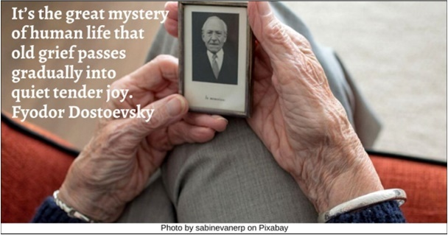

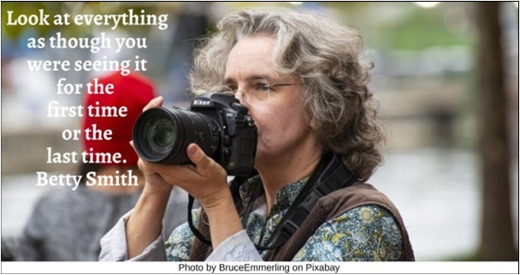



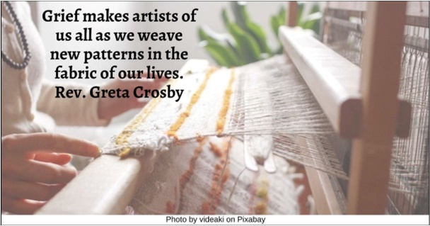

Resources for Children
2.0: Wisdom Stories
The Tapestry of Faith stories are not listed since those are easily accessible in the curricula listed at 4.0 & 5.0:
2.1: Missing Feliz by Rev. Heather Lynn Hanson (662 words)
Once upon a time, a girl named Ramona and a boy named Roberto had a wonderful dog. They named the dog Feliz because he was so happy when they came home from school each day. He bounded toward them, barking and tail wagging madly. His sandy brown coat was sort of wavy around the shoulders but straight and smooth around his haunches. Under his chin he had a ruff of fur that Ramona liked to tangle her fingers in. He had dark silky ears that Roberto liked to stroke. Feliz was always getting burrs caught in his hair, so the children took turns every day brushing his coat.
With their dog, Ramona and Roberto would roam their neighborhood. Sometimes Feliz would run ahead, chasing a squirrel. When they went to the pond, Feliz would swim with them. Sometimes they would sit on a tree stump and the dog would sit quietly beside them. His tongue hung out and his tail wagged as he rested. Once in a while, if something sad happened at school, the children would tell Feliz all about it. He would look at them with his brown eyes, and it seemed like he understood. When they walked to the supermarket, sometimes bigger kids would try to tease Ramona and Roberto, but Feliz growled at them, and the bigger kids left the children alone. They learned to walk and not be afraid when they walked with Feliz. They loved Feliz very much, and Feliz loved them.
Then one day something terrible happened. Feliz got very, very sick. He must have eaten something very bad for him because he never got well and he died. The children cried and cried. And then they found a place in the garden to bury him and they wrapped up his body in a pretty scarf and covered him up with dirt, and planted a pretty bush by the grave. And they thought about all the fun they had with Feliz and how much they missed him.
A few days later, Ramona was walking home from school, and a dog came bounding toward her, tail wagging. It reminded her a lot of Feliz. “It’s like Feliz is part of that dog, too,” she told her brother. Roberto saw a squirrel running like crazy across the school yard. It brought back memories of how Feliz chased squirrels. “Do you suppose that squirrel saw Feliz’s ghost?” he said, and the children laughed.
Ramona and Roberto had to walk through the neighborhood where the mean kids lived. The children remembered how confident they used to feel with Feliz at their heels. They decided to pretend that Feliz was walking beside them, and they walked bravely past the other kids. The bigger kids said some things, but Roberto and Ramona kept on going, thinking Feliz would be with them if he could be.
That night they asked their dad: “Do you think dogs turn into ghosts or angels or something when they die?”
“I don’t know,” said dad. “You miss Feliz a lot, don’t you?”
“Yes, I miss brushing his coat.”
“And I miss his silky ears and his waggly tail.”
“Sometimes it seems like he’s here somewhere, but just out of sight.”
“Sometimes I see another dog, and I think it’s Feliz,” said Ramona.
Mother said, “You still imagine him sometimes, don’t you? How he was so friendly and playful—all the ways he was special to you? You can see him even when he isn’t here.” The children nodded.
“You can feel happy for the wonderful dog he was, even though you are sad, too. His love lives on in your memory. Maybe that’s what it means to live forever—remembering the friends you love and who love you, and, letting that love fill you with happiness, and live inside you. When you remember Feliz, part of him lives again in you.”
“I like that,” said Ramona and Roberto. And they smiled.
Do you like that idea?
Source: https://www.uua.org/worship/words/reading/5951.shtml

2.2: Wisdom Story: The Mish-Mash Heart, from Love Connects Us, adapted (460 words)
At a multigenerational event at a Unitarian Universalist congregation, everyone was encouraged to create a heart. They were given some construction paper and some glue, and some markers to design their heart. Emily worked diligently to create the most perfect, beautiful heart she could. It even had glitter in the shape of diamonds all around the outside.
As she was helping to clean up, she noticed the heart of one woman who was around the same age as her grandmother sitting at a nearby table. It was a mish-mash mess of odd colors and had pieces that were ripped and torn glued haphazardly upon it. Parts were wrinkled and crinkled, and there was even a little hole in it!
Thinking there was something wrong, Emily offered to help the woman fix her heart. But the woman merely smiled and explained that there was nothing wrong with her heart; it merely revealed all the things which had happened to her in her life. She said there were happy times here: the beautiful colors and designs represented when she first met her husband, their wedding, and the birth of each of their three children. There were other beautiful parts, too, which stood for watching her children taking their first steps on their own, riding a bike for the first time, and graduating from college.
“But what about all the rips and tears and wrinkles?” Emily asked. “Why are they there?”
These were for the sad times in her life, the woman explained. The time her best friend was stricken with measles, the time someone lied or did something to hurt her feelings, the hole that was left when her husband died, and the grief that overwhelmed her. “In fact, every time a person comes into my life that I care about,” she explained, “they take a piece of my heart with them.”
This distressed Emily, thinking of the woman having to give part of her heart away to others. “But what happens if you give it all away?” she asked. “You’ll be left with nothing.”
“No, I won’t,” the woman responded with a smile. “Because you see, they give me a piece of theirs as well.”
Emily looked down at her beautiful, perfect heart with the glitter and the designs she had worked so hard to make. Then she looked again at the woman’s mish-mashed heart with the jagged colors, rips, and wrinkles. Without hesitation, Emily ripped a piece off of her perfect heart and handed it to the woman.
“Thank you,” the woman said as she placed it with her mish-mash heart and tore off a piece to hand to Emily. And then Emily glued the new piece onto her heart. She thought that now her heart looked even more beautiful.
Source: https://www.uua.org/re/tapestry/children/loveconnects/session3/161723.shtml

3.0: Children’s Books
Grief

3.1: The Tenth Good Thing About Barney by Judith Viorst (Author) and Erik Blegvad (Illustrator) (1987)


“My cat Barney died this Friday. I was very sad. My mother said we could have a funeral for him, and I should think of ten good things about Barney so I could tell them....

“But the small boy who loved Barney can only think of nine. Later, while talking with his father, he discovers the tenth—and begins to understand.”

Video Link: https://www.youtube.com/watch?v=yxgU61g27V8 (4:30)

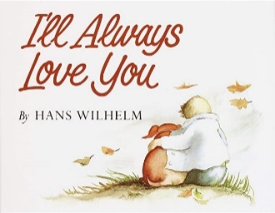
3.2: I’ll Always Love You by Hans Wilhelm (1988)
“I’ll Always Love You by Hans Wilhelm explores the love between humans and their pets through the story shared by a young narrator about his dog, Elfie, and their life together. The book shows the boy caring for Elfie as she ages and his family’s grief when she dies of old age. The boy is sad that Elfie is gone but consoles himself that his dog always knew how much she was loved.”
Video Link: https://www.youtube.com/watch?v=UiBJ8ovAGoU (3:12)

3.3: Nzingha and Saying Goodbye by Enomwoyi Damali (Author) and Michael Powell (Illustrator) 2020
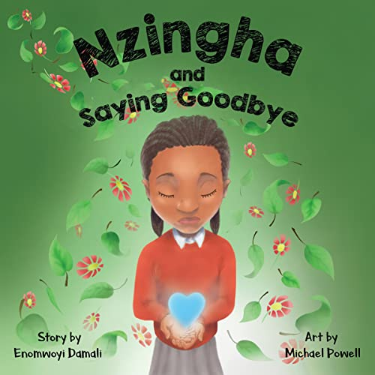
“When someone dies, we may feel several different emotions. Join Nzingha and the children in Amber Class as they share some of these feelings when their teacher tells them about the death of their special pet.”
Video Link: https://www.youtube.com/watch?v=QIrDqVmyeKc (5:12)

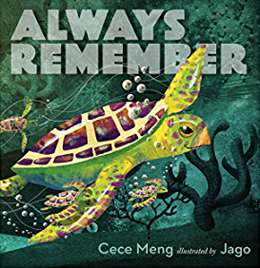
3.4: Always Remember by Cece Meng (Author) and Jago (Illustrator) (2016)
“After Old Turtle swims his last swim and breathes his last breath, and the waves gently take him away, his friends lovingly remember how he impacted each and every one of them. As the sea animals think back on how much better Old Turtle made their lives and their world, they realize that he is not truly gone, because his memory and legacy will last forever.”
Video Link: https://www.youtube.com/watch?v=9riySyMz8Kk (4:35)

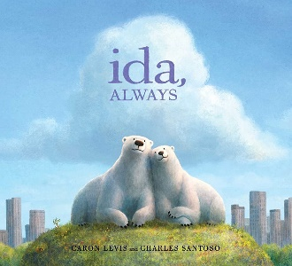
3.5: Ida, Always by Caron Levis (Author) and Charles Santoso (Illustrator) (2016)
“Gus lives in a big park in the middle of an even bigger city, and he spends his days with Ida. Ida is right there. Always.
“Then one sad day, Gus learns that Ida is very sick, and she isn’t going to get better. The friends help each other face the difficult news with whispers, sniffles, cuddles, and even laughs. Slowly Gus realizes that even after Ida is gone, she will still be with him—through the sounds of their city, and the memories that live in their favorite spots.”
Video Link: https://www.youtube.com/watch?v=PrNbE-U4OSk (8:21)


3.6.: The Rabbit Listened by Cori Doerrfeld (2018)
“When something sad happens, Taylor doesn’t know where to turn. All the animals are sure they have the answer. The chicken wants to talk it out, but Taylor doesn’t feel like chatting. The bear thinks Taylor should get angry, but that’s not quite right either. One by one, the animals try to tell Taylor how to act, and one by one they fail to offer comfort. Then the rabbit arrives. All the rabbit does is listen . . . which is just what Taylor needs.
“With its spare, poignant text and irresistibly sweet illustration, The Rabbit Listened is about how to comfort and heal the people in your life, by taking the time to carefully, lovingly, gently listen.”
Video Link: https://www.youtube.com/watch?v=rHPoj53dy8o (3:37)


3.7: Badger’s Parting Gifts by Susan Varley (1984)
“All the woodland creatures—Mole, Frog, Fox, and Rabbit—love old Badger, who is their confidante, advisor, and friend. When he dies, they are overwhelmed by their loss. Then they begin to remember and treasure the memories he left them.”
Video Link: https://www.youtube.com/watch?v=tRTRABhJTbo (5:57)

3.8: The Goodbye Book by Todd Parr (2015)

“Through the lens of a pet fish who has lost his companion, Todd Parr tells a moving and wholly accessible story about saying goodbye. Touching upon the host of emotions children experience, Todd reminds readers that it’s okay not to know all the answers, and that someone will always be there to support them. An invaluable resource for life’s toughest moments.”
Video: https://www.youtube.com/watch?v=vg2cJIrNKGY (2:56)

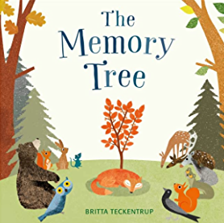
3.9: The Memory Tree by Britta Teckentrup (2014)
“Fox has lived a long and happy life in the forest, but now he is tired. He lies down in his favourite clearing, and falls asleep forever. Before long, Fox’s friends begin to gather in the clearing. One by one, they tell stories of the special moments that they shared with Fox. And so, as they share their memories, a tree begins to grow, becoming bigger and stronger with each memory, sheltering and protecting all the animals in the forest, just as Fox did when he was alive.”
Video Link: https://www.youtube.com/watch?v=BHX8dZjhJMM&t=60s (5:22)

3.10: Michael Rosen’s Sad Book by Michael Rosen, (Author) and Quentin Blake (Illustrator) (2005)
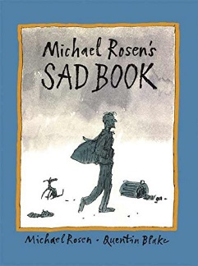
“Sad things happen to everyone, and sometimes people feel sad for no reason at all. What makes Michael Rosen sad is thinking about his son, Eddie, who died suddenly at the age of eighteen. In this book the author writes about his sadness, how it affects him, and some of the things he does to cope with it — like telling himself that everyone has sad stuff (not just him) and trying every day to do something he can be proud of.”
Video Link: https://www.youtube.com/watch?v=X5lx69-F3cA (6:28)

3.11: Tear Soup: A Recipe for Healing After Loss by Pat Schwiebert & Chuck DeKlyen (Authors) and Taylor Bills (Illustrator) (2005)
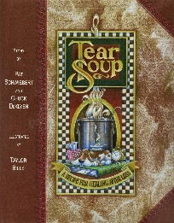
“If you are going to buy only one book on grief, this is the one to get! It will validate your grief experience, and you can share it with your children. You can leave it on the coffee table so others will pick it up, read it, and then better appreciate your grieving time. Grand’s Cooking Tips section at the back of the book is rich with wisdom and concrete recommendations. Better than a casserole!”
Video Link: https://www.youtube.com/watch?v=xm0ssmV7KSU (12:22)

3.12: The Memory Box: A Book About Grief by Joanna Rowland (Author) and Thea Baker (Illustrator) (2017)
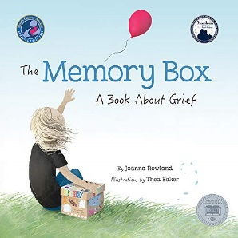
“‘I’m scared I’ll forget you...’ From the perspective of a young child, Joanna Rowland artfully describes what it is like to remember and grieve a loved one who has died. The child in the story creates a memory box to keep mementos and written memories of the loved one, to help in the grieving process. Heartfelt and comforting, The Memory Box will help children and adults talk about this very difficult topic together. The unique point of view allows the reader to imagine the loss of any they have loved - a friend, family member, or even a pet. A parent guide in the back includes information on helping children manage the complex and difficult emotions they feel when they lose someone they love, as well as suggestions on how to create their own memory box.”

Video Link: https://www.youtube.com/watch?v=KEeS1X8LSRU (3:32)

3.13: Nana Upstairs and Nana Downstairs by Tomie dePaola (2000)
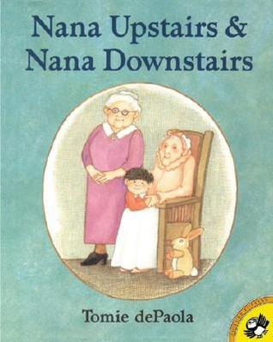
“Tommy is four years old, and he loves visiting the home of his grandmother, Nana Downstairs, and his great-grandmother, Nana Upstairs. But one day Tommy’s mother tells him Nana Upstairs won’t be there anymore, and Tommy must struggle with saying good-bye to someone he loves.”
Video Link: https://www.youtube.com/watch?v=Xpj-Coj-AtQ (7:41)

3.14: One Wave at a Time: A Story about Grief and Healing by Holly Thompson (Author) and Ashley Crowley (Illustrator) (2018)
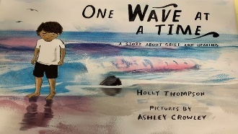
“After his father dies, Kai experiences all kinds of emotions: sadness, anger, fear, guilt. Sometimes they crash and mix together. Other times, there are no emotions at all―just flatness. As Kai and his family adjust to life without Dad, the waves still roll in. But with the help of friends and one another, they learn to cope―and, eventually, heal. A lyrical story about grieving for anyone encountering loss.”
Video Link: https://www.youtube.com/watch?v=db5eVeFSsFw (9:57)

3.15: The Scar by Charlotte Moundlic (Author) and Olivier Tallec (Illustrator) (2011)
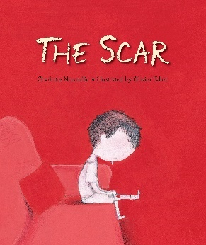
“When the boy in this story wakes to find that his mother has died, he is overwhelmed with sadness, anger, and fear that he will forget her. He shuts all the windows to keep in his mother’s familiar smell and scratches open the cut on his knee to remember her comforting voice. He doesn’t know how to speak to his dad anymore, and when Grandma visits and throws open the windows, it’s more than the boy can take — until his grandmother shows him another way to feel that his mom’s love is near.”
Video Link: https://www.youtube.com/watch?v=YfPzvOrXnAI (10:07)

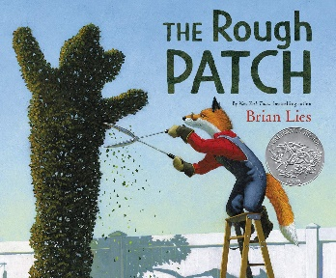
3.16: The Rough Patch by Brian Lies (2018)

“Evan and his dog do everything together, from eating ice cream to caring for their prize-winning garden, which grows big and beautiful. One day the unthinkable happens: Evan’s dog dies. Heartbroken, Evan destroys the garden and everything in it. The ground becomes overgrown with prickly weeds and thorns, and Evan embraces the chaos.

“But beauty grows in the darkest of places, and when a twisting vine turns into an immense pumpkin, Evan is drawn out of his isolation and back to the county fair, where friendships—old and new—await.”
Video Link: https://www.youtube.com/watch?v=ezsUPXkC-R4 (3:44)

3.17: Rabbit and the Motorbike by Kate Hoefler (Author) and Sarah Jacoby (Illustrator) (2019)
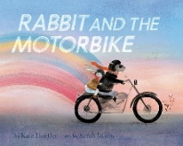
“A timeless fable of the journey from grief to acceptance that will touch every reader: Rabbit isn’t sure he’ll ever be brave enough to go on an adventure. He’s a homebody who lives in a quiet field of wheat he dreams of leaving every night. His world is enlarged by his friend Dog and Dog’s tales of motorbike adventures. But one day, Dog is gone, and with him, go the stories Rabbit loves so much. Dare Rabbit pick up the motorbike and live his own story?”

Video Link: https://www.youtube.com/watch?v=YJj8TdsXamg (3:59)

3.18: The Invisible String by Patrice Karst (Author) and Geoff Stevenson (Illustrator) (2000)
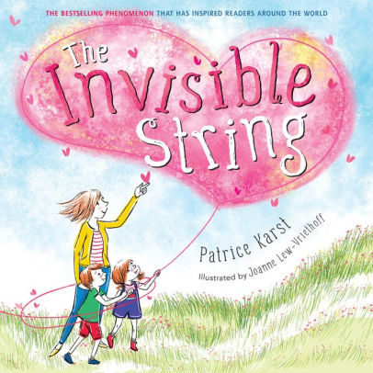
“Parents, educators, therapists, and social workers alike have declared The Invisible String the perfect tool for coping with all kinds of separation anxiety, loss, and grief. In this relatable and reassuring contemporary classic, a mother tells her two children that they’re all connected by an invisible string. ‘That’s impossible!’ the children insist, but still they want to know more: ‘What kind of string?’ The answer is the simple truth that binds us all: An Invisible String made of love. Even though you can’t see it with your eyes, you can feel it deep in your heart, and know that you are always connected to the ones you love. Does everybody have an Invisible String? How far does it reach? Does it ever go away? This heartwarming picture book for all ages explores questions about the intangible yet unbreakable connections between us, and opens up deeper conversations about love.
Video Link: https://www.youtube.com/watch?v=2rZNTFf35Aw (5:26) illustrations by Joanne Lew-Vriethoff

Video Link: https://www.youtube.com/watch?v=U4uPTuGTy6I (6:47) illustrations by Geoff Stevenson

3.19: The Invisible Leash: An Invisible String Story About the Loss of a Pet by Patrice Karst (Author) and Joanne Lew-Vriethoff (Illustrator) (2021)

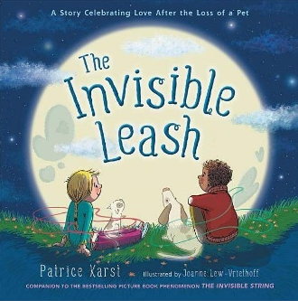
“‘When our pets aren’t with us anymore, an Invisible Leash connects our hearts to each other. Forever.’ That’s what Zack’s friend Emily tells him after his dog dies. Zack doesn’t believe it. He only believes in what he can see. But on an enlightening journey through their neighborhood—and through his grief—he comes to feel the comforting tug of the Invisible Leash. And it feels like love.”

Video Link: https://www.youtube.com/watch?v=hEUdo3y7C9E (8:24)

3.20: Maybe Tomorrow? by Charlotte Agell (Author) and Ana Ramírez González (Illustrator) (2019)
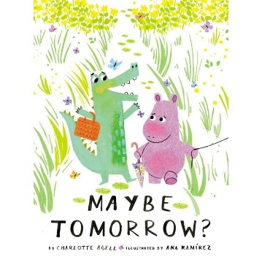
“Elba has a big block. She’s been dragging it around for a long time. Norris dances everywhere he goes, even uphill. He is always surrounded by a happy cloud of butterflies. Can Norris and his butterflies help ease Elba’s sadness and convince her to join them on a trip to the ocean?
“This tender exploration of loss illuminates the sustaining power of kindness, empathy, and friendship. It will resonate with anyone who has experienced hardship or grief, from the death of a loved one or a pet, to the transition to a new home, family situation, or learning environment.”

Video Link: https://www.youtube.com/watch?v=tO0atP_hDt8 (5:11)

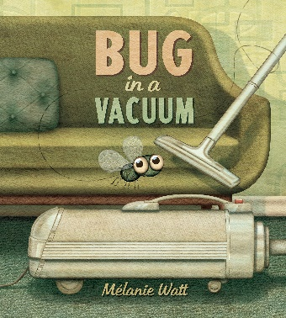
3.21: Bug in a Vacuum by Melanie Watt (2015)
“A bug flies through an open door into a house, through a bathroom, across a kitchen and bedroom and into a living room ... where its entire life changes with the switch of a button. Sucked into the void of a vacuum bag, this one little bug moves through denial, bargaining, anger, despair and eventually acceptance -- the five stages of grief -- as it comes to terms with its fate. Will there be a light at the end of the tunnel? Will there be dust bunnies in the void? A funny, suspenseful and poignant look at the travails of a bug trapped in a vacuum.”
Video Link: https://www.youtube.com/watch?v=pfErtkJxv58 (7:08)

3.22: Why Do I Feel So Sad? A Grief Book for Children by Tracy Lambert-Prater LPC (Author) and Elena Napoli (Illustrator) (2020)
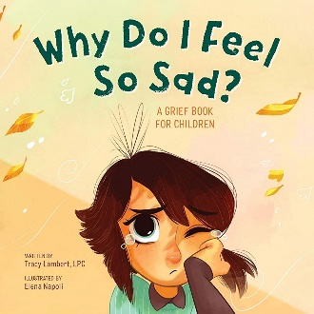
“Why Do I Feel So Sad? is an inclusive, age-appropriate, illustrated kid’s book designed to help young children understand their own grief. The examples and beautiful illustrations are rooted in real life, exploring the truth of loss and change, while remaining comforting and hopeful.
“Broad enough to encompass many forms of grief, this book reassures kids that they are not alone in their feelings and even suggests simple things they can do to feel better, like drawing, dancing, and talking to friends and family.”
Video Link: https://www.youtube.com/watch?v=AJnSSsvXX9I (5:35)

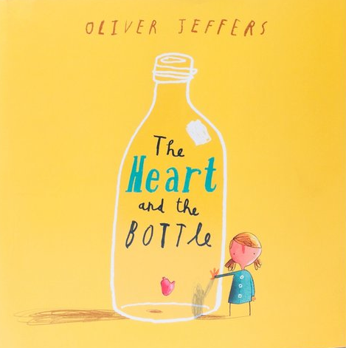
3.23: The Heart and the Bottle by Oliver Jeffers (2010)
“There is a wonder and magic to childhood. We don’t realize it at the time, of course . . . yet the adults in our lives do. They encourage us to see things in the stars, to find joy in colors and laughter as we play.
“But what happens when that special someone who encourages such wonder and magic is no longer around? We can hide, we can place our heart in a bottle and grow up . . . or we can find another special someone who understands the magic. And we can encourage them to see things in the stars, find joy among colors and laughter as they play.”
Video Link: https://www.youtube.com/watch?v=3Q4W2P4HgcY (5:15)

3.24: You’ll Find Me by Amanda Rawson Hill (Author) and Joanne Lew-Vriethoff (Illustrator) (2020)
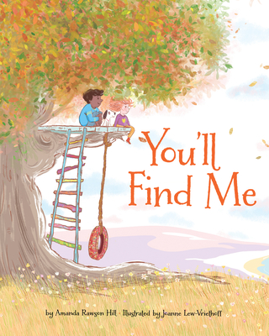
“Loss becomes remembrance in this book that offers tender ways to pay tribute to, and meaningfully incorporate, a loved one’s lost presence into present and future life experiences. Be it departed friends, family, pets, and more, memories can carry us beyond the precious moments we have together to keep the ones we loved before in mind forever.
“Throughout the book the omnipresent narrator encourages thoughtful reflection on the empty spaces left by the loss. The gentle scenes portrayed inspire recovery from sadness and honor those who are absent. This lyrical heartful story provides consent and gently encourage readers to move to a place of peace and acceptance despite the absence.”
Video Link: https://www.youtube.com/watch?v=qjEuJk10cCI (3:54)

3.25: Grandpa’s Stories by Joseph Coelho (Author) and Allison Colpoys (Illustrator) (2019)
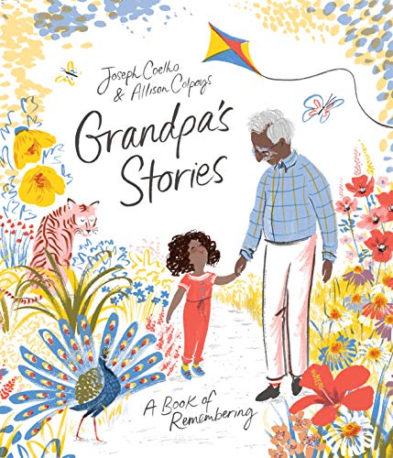
“One young girl reflects on a year with her beloved grandpa. She remembers the fields and parks they explored in the springtime and the old toys they fixed up in the summer. She remembers the handmade gifts they exchanged in the fall and the stories Grandpa told by the fi re each winter. But this year, the girl must say good-bye to Grandpa. In the face of her grief, she is determined to find a way to honor him. She decides to record her Grandpa’s stories in the notebook he made for her and carry Grandpa with her as she grows.”
Video Link: https://www.youtube.com/watch?v=Y3xoMO-YQq8 (4:17)

3.26: My Father’s Arms Are a Boat by Stein Erik Lunde (Author), Øyvind Torseter (Illustrator) and Kari Dickson (Translator) (2013)
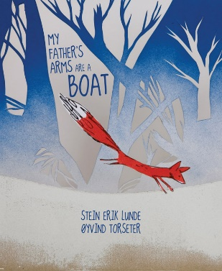
It’s quieter than it’s ever been. Unable to sleep, a young boy climbs into his father’s arms. Feeling the warmth and closeness of his father, he begins to ask questions about the birds, the foxes, and whether his mom will ever wake up. They go outside under the starry sky. Loss and love are as present as the white spruces, while the father’s clear answers and assurances calm his worried son. Here we feel the cycles of life and life’s continuity, even in the face of absence and loss, so strongly and clearly that we know at the end that everything will, somehow, be all right.
Video Link: https://www.youtube.com/watch?v=XCCIziQC8HE (6:41)

3.27: Goodbye, Brecken by David Lupton (2013)


“Goodbye, Brecken is an evocative and somber telling of a girl’s loss surrounding the death of her dog. With this loss comes her first experience with grief and profound sadness. As she comes to accept Brecken’s death, she can deal with her grief and remember her lost dog with happiness.”
Video Link: https://www.youtube.com/watch?v=tUjvU_tpD1M (6:15, story starts at 1:15)

Sadness
3.28: Felix After the Rain by Dunja Jogan (Author & Illustrator) and Olivia Hellewell (Translator) (2020)
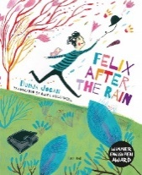
“A young man called Felix hides all of his sorrow inside a large black suitcase that he carries with him wherever he goes. One day, a small boy opens the suitcase whilst Felix is sleeping. Felix wakes and the tears that he had been carrying for so long suddenly pour from him. Felix is uplifted, free and his heart is full of joy. Felix embraces the world, and the world embraces him. This book is a wonderful resource for young children to talk about sad feelings and how they might feel better if they confide in another person.”
Video Link: https://www.youtube.com/watch?v=hH7FgcaJpSo (2:44)

3.29: Don’t Need Friends by Carolyn Crimi (Author) and Lynn Munsinger (Illustrator) (2001)

“Rat’s best friend moves out of the Junkyard. Devastated, Rat masks his sadness with an attitude that he doesn’t need friends. He rejects all help and friendships from neighbors. Dog moves into the Junkyard with the same, if not worse, attitude. Rat and Dog have met their match in each other.

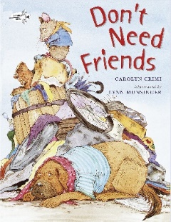
“Then disaster strikes with cold weather and food. It forces Dog and Rat to acknowledge that they care for each other and how they need one another.

“So often when hurting, people hide behind a mask of grumpiness or artificial friendliness. Meanwhile, they are hurting inside. Don’t Need Friends teach children empathy and to look beyond the obvious. The story shows the benefits of lasting relationships like friendship, and the pain when losing a friend.”

Video Link: https://www.youtube.com/watch?v=bW1cukmcJvM (6:42)

3.30: When Sadness is at Your Door by Eva Eland (2019)

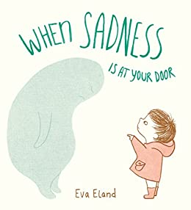
“Sadness can be scary and confusing at any age! When we feel sad, especially for long periods of time, it can seem as if the sadness is a part of who we are--an overwhelming, invisible, and scary sensation.

“In When Sadness Is at Your Door, Eva Eland brilliantly approaches this feeling as if it is a visitor. She gives it a shape and a face, and encourages the reader to give it a name, all of which helps to demystify it and distinguish it from ourselves. She suggests activities to do with it, like sitting quietly, drawing, and going outside for a walk. The beauty of this approach is in the respect the book has for the feeling, and the absence of a narrative that encourages the reader to ‘get over’ it or indicates that it’s ‘bad,’ both of which are anxiety-producing notions.”

Video Link: https://www.youtube.com/watch?v=yPSWY7C73fo (2:01)

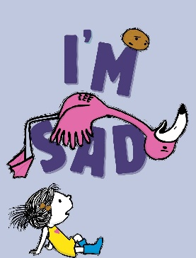
3.31: I’m Sad by Michael Ian Black (Author) and Debbie Ridpath Ohi (Illustrator) (2018)

“A girl, a potato, and a very sad flamingo star in this charming sequel to I’m Bored…. Everyone feels sad sometimes—even flamingos.

“Sigh. When Flamingo announces he’s feeling down, the little girl and Potato try to cheer him up, but nothing seems to work. Not even dirt! (Which usually works for Potato.) Flamingo learns that he will not always feel this way. And his friends learn that sometimes being a friend means you don’t have to cheer someone up. You just have to stick by your pal no matter how they feel. Even if they’re a potato.”

Video Link: https://www.youtube.com/watch?v=NwSLEkE0DmA (3:59)


3.32: What to Do When You’re Feeling Blue by Andi Cann (2019)
“Sadness happens. Let’s help kids cope with it. Children aren’t always prepared for the emotions that overcome them. Adults aren’t either.
“Kappy is a regular little kid who feels a variety of emotions all day long. Sometimes she feels happy and glad, sometimes she feels blue and sad. Talking with her Dad about her feelings helps her understand her feelings and gives her ideas for things she can try when some days are blue.
“Parents appreciate the opportunity to talk with their children about happiness and sadness. It honors emotions while problem-solving how to perk up when feeling sad.”

Video Link: https://www.youtube.com/watch?v=v_Ehfo6wtPQ (6:15)

Death
3.33: Lifetimes: The Beautiful Way to Explain Death to Children by Bryan Mellonie (Author) and Robert Ingpen (Author) (1983)
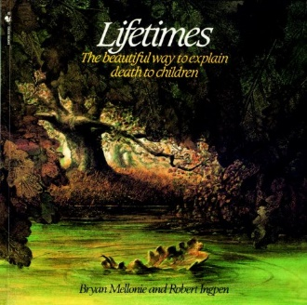
“Lifetimes is a moving book for children of all ages, even parents too. It lets us explain life and death in a sensitive, caring, beautiful way. Lifetimes tells us about beginnings. And about endings. And about living in between. With large, wonderful illustrations, it tells about plants. About animals. About people. It tells that dying is as much a part of living as being born. It helps us to remember. It helps us to understand.”
Video Link: https://www.youtube.com/watch?v=__e6ihNSQ3c (5:51)

3.34: Something Very Sad Happened: A Toddler’s Guide to Understanding Death by Bonnie Zucker (Author) and Kim Fleming (Illustrator) (2016)
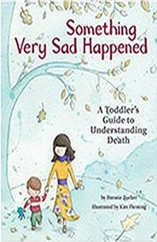
“When a loved one dies, it can be hard to know how to explain it to a young child, particularly if you are grieving the loss yourself. Written at a developmental level that is appropriate for two- and three-year-olds, the story explains death; lets children know that it is okay to feel sad; and reassures children that they can still love the person who died, and the person who died will always love them.
Since the two- to three-year-old child cannot read, this story is intended to be personalized; certain words are color-coded in red to cue to you to substitute with the appropriate names and pronouns for the person who died.”
Video Link: https://www.youtube.com/watch?v=zHaspeyGYFQ (2:58)

3.35: What Happens When a Loved One Dies? Our First Talk About Death by Dr. Jillian Roberts (Author) and Cindy Revell (Illustrator) (2022)
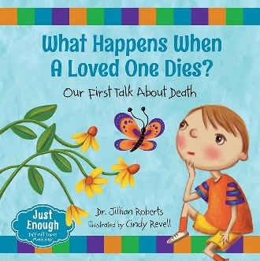
“Whether children are experiencing grief and loss for the first time or simply curious, it can be difficult to know how to talk to them about death.
“Using questions posed in a child’s voice and answers that start simply and become more in-depth, this book allows adults to guide the conversation to a natural and reassuring conclusion. Additional questions at the back of the book allow for further discussion.”
Video Link: https://www.youtube.com/watch?v=d_r5VkS8jJw (8:01, story ends at 5:15)

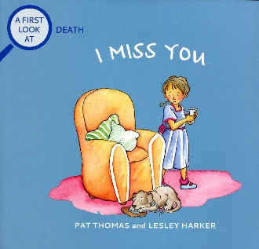
3.36: I Miss You by Pat Thomas (Author) and Lesley Harker (Illustrator) (2001)
“When a close friend or family member dies, it can be sad for kids and difficult for them to express the big feelings they are experiencing. This book will help explain in a gentle way that death is a natural complement to life and that grief and a sense of loss are normal feelings to have following the death of a loved one.”
Video Link: https://www.youtube.com/watch?v=-vtJKJkl9kc (3:52)

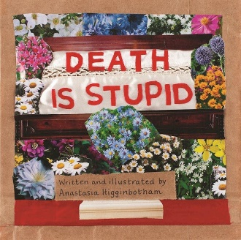
3.37: Death Is Stupid by Anastasia Higginbotham (2020)
“When someone we love dies, adults often say things like, ‘She’s in a better place now,’ or ‘I know how you feel.’ You do not, one little boy thinks after his grandma passes away. Caught in the swirl of anger, confusion, and fear that accompanies grief and mourning, he doesn’t just think death is unfair—he thinks death is stupid. It takes him some time, but when he starts sharing cherished memories of his grandma and working in her garden, he starts to feel just a little bit better. Necessary, beautiful, and ultimately reassuring, Death Is Stupid helps make death a little less scary—for kids and adults.” A very thoughtful and engaging book.
Video Link: https://www.youtube.com/watch?v=DtAOWqihHe0 (11:15)
Video Link: https://www.youtube.com/watch?v=hnWe9N1EyyY (15:45) (The author explains the book in detail.)

3.38: Cry, Heart, But Never Break by Glenn Ringtved (Author), Charlotte Pardi (Illustrator) and Robert Moulthrop (Translator) (2016)
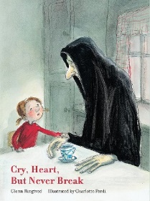
“Aware their grandmother is gravely ill, four siblings make a pact to keep death from taking her away. But Death does arrive all the same, as it must. He comes gently, naturally. And he comes with enough time to share a story with the children that helps them to realize the value of loss to life and the importance of being able to say goodbye.”
Video Link: https://www.youtube.com/watch?v=w-sIx7MB30U (7:14)
3.39: Is Daddy Coming Back in a Minute? Explaining (sudden) death in words very young children can understand by Elke Barber (now Elke Thompson) & Alex Barber (Authors) and Anna Jarvis (Illustrator) (2016)
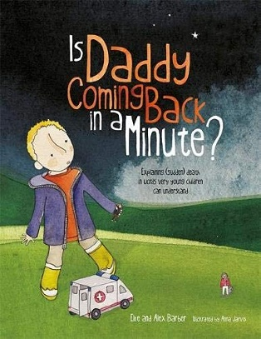
When we were on a No Girls Allowed! holiday, my daddy’s heart stopped beating and I had to find help all by myself. He was very badly broken. Not even the ambulance people could help him...
This honest, sensitive and beautifully illustrated picture book is designed to help explain the concept of death to children aged 3-7. Written in Alex’s own words, it is based on the real-life conversations that Elke Barber had with her then three-year-old son, Alex, after the sudden death of his father. The book provides reassurance and understanding to readers through clear and honest answers to the difficult questions that can follow the death of a loved one, and carries the invaluable message that it is okay to be sad, but it is okay to be happy, too.
Video Link: https://www.youtube.com/watch?v=vrsaioNe_8M (12:15)

3.40: What Happened to Daddy’s Body? Explaining what happens after death in words very young children can understand by Elke Barber (now Elke Thompson) & Alex Barber (Authors) and Anna Jarvis (Illustrator) (2020)
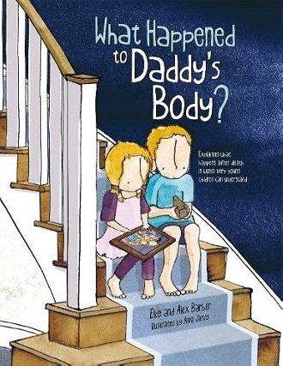
“My daddy died when I was (one...two...) three years old. Today we are out in the garden. It always makes me think about my daddy because he LOVED his garden. Sometimes, I wonder what happened to my daddy’s body...
“This picture book aims to help children aged 3+ to understand what happens to the body after someone has died. Through telling the true story of what happened to his daddy’s body, we follow Alex as he learns about cremation, burial and spreading ashes. Full of questions written in Alex’s own words, and with the gentle, sensitive and honest answers of his mother, this story will reassure any young child who might be confused about death and what happens afterwards. It also reiterates the message that when you have experienced the loss of a loved one, it is okay to be sad, but it is okay to be happy, too.”
Video Link: https://www.youtube.com/watch?v=-xW2pMFwzQY (13:22)

4.0: Curriculum & Theme-Based Classroom Activities for Children

from Tapestry of Faith
4.1: Chalice Children: A Program about Our Unitarian Universalist Community for Preschoolers
4.1.1: Session 13: Feeling Sad
Link: https://www.uua.org/re/tapestry/children/chalicechildren/session13
The sad feelings in a response to a death can help children begin to understand grief.
“Participants will:
- Learn that everyone has sad feelings and that death is a natural part of life
- Know that a memorial service is one way that we can comfort people when someone has died
- Understand that our congregation is a safe place to share our feelings and questions about death and loss.”
4.1.2: Session 35: Easter
Link: https://www.uua.org/re/tapestry/children/chalicechildren/session35
“Participants will:
- Connect the holiday of Easter with the renewal of spring
- Understand Easter’s connection to Jesus through a simplified story of Jesus as a beloved teacher.”

4.2: Creating Home: A Program on Developing a Sense of Home Grounded in Faith for Grades K-1
4.2.1: Session 16: Memories of Home
Link: https://www.uua.org/re/tapestry/children/home/session16
Memories play a central role in grief as we remember a loved one who has died and often memories of home are connected with our memories of the loved one. For those who have lost a home to destruction or are an immigrant, the loss of home may cause grief. Exploring with children how this might feel like can introduce grief through that sadness.
“This session will:
- Help each child articulate their unique contributions to their family home and faith home
- Model ways to articulate, honor, and rely upon one’s memories of home with activities that provide closure to the Creating Home “journey”
- Convey that memories of our Unitarian Universalist faith home and our family home can sustain us in our daily lives”

4.3: Wonderful Welcome: A Program for Children Grades K-1
4.3.1: Session 8: The Gift Of Families
Link: https://www.uua.org/re/tapestry/children/welcome/session8
In the story, The Picture on The Kitchen Wall, Chang Kung, in a way, became an ancestor to countless Chinese families through his picture on kitchen walls. We are made, in part, by our family and our memories of our family, and memories are so important in grief as we remember loved ones.
“This session will:
- Guide participants to consider the intangible gifts they bring to and receive from members of their families
- Explore ways to share intangible gifts within our families
- Apply the first and second Unitarian Universalist Principles — the inherent worth and dignity of every person, and justice, equity, and compassion in human relations —to our family life”

4.4: Love Surrounds Us: A Program on the UU Principles and Beloved Community for Grades K-1
4.4.1: Session 7: Love Surrounds Us in Ritual
Link: https://www.uua.org/re/tapestry/children/lovesurrounds/session7
Rituals are an important part how we deal with the death of a loved one, and flowers are often featured in such rituals. Like the flower ceremony, memorial services are surrounded by love and acceptance.
“Participants will:
- Learn that ritual serves the purpose of gathering people in shared faith
- Learn the origin of the flower ceremony and its role in contemporary Unitarian Universalist worship
- Experience a ritual that affirms acceptance and love, by participating in a flower ceremony.”

4.5: World of Wonder: A Program on the Seven Principles of Unitarian Universalism for Grades K-1
4.5.1: Session 3: Thanks Be for Trees!
Link: https://www.uua.org/re/tapestry/children/wonder/session3
In the story, “Amrita’s Tree,” the people in the village began to experience profound grief as the trees are cut down. In response, Amrita hugs her tree to protect it. Her bravery saves her tree and the forest. This session connects to climate grief. One line of discussion is to ask what children love about the earth and how they would feel if it was harmed. Would they feel like the people in the village as the trees were cut doen?
Watch the story read by Steve Mead at https://www.youtube.com/watch?v=B4Txat7tmNc (8:13).
A different version of the story can be viewed at https://www.youtube.com/watch?v=81iYOjRdmvY (8:18)
“This session will:
- Teach the importance of trees in our ecosystems and how trees grow and thrive in nature
- Foster a spiritual orientation of awe in relationship with the web of life
- Demonstrate the inspirational leadership of a child in India
- Empower participants as leaders in the group
- Reinforce the Seventh Unitarian Universalist Principle, respect for the interdependent web of all existence of which we are a part.”

4.6: Moral Tales: A Program on Making Choices for Grades 2-3
4.6.1: Session 4: In Another’s Shoes
Link: https://www.uua.org/re/tapestry/children/tales/session4
Empathy is an important skill in supporting people who are grieving. In the story, The Wounded Seal, the seals are grieving because they believe that the wounded seal will die. This is called anticipatory grief. Fortunately, the Seal Hunter heals the wounded seal. Did the Seal Hunter have empathy because he became a seal in the water?
“This session will:
- Give participants an opportunity to share acts of goodness that they have done (or witnessed)
- Provide a story and active experiences that demonstrate the meaning of the word ‘Empathy’ and how empathy feels
- Teach that an important part of acting out of goodness is to look at things from other perspectives besides one’s own
- Help participants learn to identify, respect and value the perspectives and experiences of others which differ from their own
- Strengthen participants’ connection to and sense of responsibility to their faith community”

4.7: Faithful Journeys: A Program about Pilgrimages of Faith in Action for Grades 2-3
4.7.1: Session 3: Welcoming Superman
Link: https://www.uua.org/re/tapestry/children/journeys/session3
In the story, A Different Kind Of Superhero, Christopher Reeve experiences profound grief because of the injuries he sustained in the horse-riding accident, and all the he lost as a result. As the story is read, can children identify some of the seven stages of grief per Elisabeth Kübler-Ross, e.g., shock, denial, anger, bargaining, depression, testing, and acceptance?
This session will:
- Use the story of Christopher Reeve and his work on behalf of people with spinal cord injuries to explore the first Unitarian Universalist Principle, the inherent worth and dignity of every person
- Educate and encourage participants to live the first Principle by being careful to welcome all people by making sure places are accessible to all
- Foster participants’ empathy
- Demonstrate how to honor different people’s individual gifts
- Teach children how they can and do express their faith — their ideas of right and wrong, their values, and their beliefs — with real actions.

4.8: Love Will Guide Us: A Program for Grades 2-3 that Applies the Wisdom of the Six Sources to the Big Questions
4.8.1: Session 6: Love Is Eternal
Link: https://www.uua.org/re/tapestry/children/loveguide/session6
The focus on death facilitates the exploration of love, grief, and remembrance through the story and other activities.
“Participants will:
- Learn the sixth Unitarian Universalist Source—in children’s language, ‘The harmony of nature and the sacred circle of life’
- Understand death’s role in the cycle of human life, through a Malagasy story
- Explore ways people stay with us after they die through our memories and their loving acts
- Experience Unitarian Universalist ways to mark the loss of a loved one and honor them after death, through a craft activity and a ritual of love and remembrance.”

4.9: Signs of Our Faith: A Program about Being UU Every Day for Grades 2-3
4.9.1: Session 8: Memorial Rituals
Link: https://www.uua.org/re/tapestry/children/signs/session8
The focus of this session facilitates an exploration of grief as well as Easter through the story about Jesus.
“Participants will:
- Create a memorial ritual
- Understand that death is a part of life
- Understand that while Unitarian Universalist memorial rituals vary, all share the goals of helping us (1) acknowledge our loss and (2) celebrate the loved one’s life—indeed, all life—as sacred
- Discover rituals and signs their UU congregation uses when someone dies
- Explore the concept of a person living on after their physical death in other people’s remembered experiences of them, through a story of Jesus.”

4.10: Toolbox of Faith: A Program That Helps Children Discover the Uses of Faith, Grades 4-5
4.10.1: Session 6: Expression (Paintbrush)
Link: https://www.uua.org/re/tapestry/children/toolbox/session6
The story, “The Cellist of Sarajevo,” is about the resilience of Vedran Smailovic, (1956-) the cellist who played for 22 days for the 22 people killed in the bakery explosion in Sarajevo. While we might focus on his bravery, he was also likely motivated by anger, which is a stage of grief. Invite students to consider how his playing might have helped him grieve?
Seattle-based performance artist Beliz Brother (1950-) organized 22 cellists playing for 22 days in 22 locations, and teenager Jason Crowe worked to inform people about Smailovic. He formed “The Cello Cries On” organization to raise funds for a statue promoting peace: Children’s International Peace and Harmony Statue.
You may also want to use the children’s book, “Echoes from the Square” by Elizabeth Wellburn (Author) and Deryk Houston (Illustrator). See video link at https://www.youtube.com/watch?v=wMrf_sd3gkA (10:23).
The story of the statute took many turns as Wellburn notes in her post, https://elizabethtweets.wordpress.com/2012/10/21/the-childrens-international-peace-and-harmony-statue/.
You can see a photo of the statue by David Kocka at https://elizabethtweets.wordpress.com/2012/10/21/the-childrens-international-peace-and-harmony-statue/#jp-carousel-1693.
“Participants will:
- Reflect on expression as a quality of their Unitarian Universalist faith
- Engage in a variety of games which emphasize different forms of expression
- Experience an exploration of paint and movement that is focused on the process, not a finished product
- Consider which type of expression they feel most comfortable with and might use in the future
- Gain understanding that personal expression is an aspect of Unitarian Universalist faith that honors the inherent worth and dignity of every person”

4.11: Windows and Mirrors: A Program about Diversity for Grades 4-5
4.11.1: Session 12: Making Visible The Invisible
Link: https://www.uua.org/re/tapestry/children/windows/session12
In the story, Yammani and the Soji, the Soji clan were fit only for necessary but demeaning work like burying the dead. The story, itself, is like the story of the Good Samaritan, with a Soji responding when others did not. In the story, a child and a Soji are made visible. A way of extending this is to realize that grief is made visible by mourning. In the story, the Festival of Purification is important like a memorial service, which can make grief visible. How might the Soji feel about having to bury the dead? Did it make them more sensitive, such that a Soji noticed a child crying when no one else did, a child who was grieving because of what had happened? Might the burial involve a ritual of purification of the dead?
“Participants will:
- Learn a working definition of class and explore what it means to be perceived as, or perceive others as, rich, middle class, working class or poor
- Reflect on where they fit into the world socio-economically
- Discover connections to working people they do not personally know whose labor helped form the enjoyments and necessities of their lives
- Understand the guidance of our first Unitarian Universalist Principle to look past socio-economic distinctions and treat each individual as equally valuable and deserving of respect.”

4.12: Love Connects Us: A Program on Living in Unitarian Universalist Covenant for Grades 4-5
4.12.1: Session 3: Love is the Spirit of this Church
Link: https://www.uua.org/re/tapestry/children/loveconnects/session3
The old woman in the story, The Mish Mash Heart, has experienced grief as she explains In consideration of this, how does the sharing of joys and concerns help us learn about loss and grief within the congregation? How might learning about loss and grief affect our hearts?
“Participants will:
- Experience and respond to a story about how love becomes more powerful when it is given away
- Experience activities which require working together to accomplish an objective
- Understand how sharing joys and concerns together is one way people in a beloved community can support one another in good times and bad
- Reflect on how we all have a role in creating our beloved communities.”

4.13: Riddle and Mystery: A Program on the Big Questions for Grade 6
4.13.1: Session 6: Thinking of Death
Link: https://www.uua.org/re/tapestry/children/riddle/session6
The exploration of death also invites the exploration of grief.
“Participants will:
- Compare and contrast death beliefs of various religions
- Learn the perspective of a contemporary Unitarian Universalist theologian
- Consider the concept that we live on, after death, through our actions in life and in the love and memories of others
- Reflect on their own ideas about death
- Plan and/or experience a ritual to recognize the deaths of individuals in their congregation, family or community.”

4.14: Heeding the Call: A Program on Justice-making for Junior High School Youth
4.14.1: Workshop 4: The Call for Empathy
Link: https://www.uua.org/re/tapestry/youth/call/workshop4
The story, On the Trail with No More Deaths, notes at the end, “we would soon hear the news of the next unnecessary deaths that will undoubtedly come.” Seeing many of the jugs of water that they left become confiscate caused sadness. Who is grieving in the story? Why? Who else might be grieving? Why?
“Participants will:
- See empathy as an important quality in justice making and practice being more empathetic
- Learn what some UUs are doing to make immigration more just
- Share stories about empathy
- Practice teaching empathy by example
- Analyze ways language can influence social justice work
- Optional: Examine some of the root causes of increased immigration from Mexico.”

Resources for Youth
5.0: Curriculum & Theme-Based Classroom Activities for Youth
Tapestry of Faith
Youth
5.1: A Place of Wholeness: A Program for Youth Exploring Their Own Unitarian Universalist Faith Journeys
5.1.1: Workshop 4: A Theology of Love
Link: https://www.uua.org/re/tapestry/youth/wholeness/workshop4
This workshop asks “What does a theology of love cause us to do?”, “How should we be in the world if we think universal love is important?”, and “What are our congregations doing right now to live out a theology of love?” While grief is not the focus, it can be included by extension because love and grief are woven closely together. How does our theology of grief support people who are grieving?
“Participants will:
- Understand the historical roots of the Universalist theology of love as it relates to salvation and God
- Reflect on what the Universalist theology of love means for them and for Unitarian Universalists today, including how they live it out; what its limits are, and what it says about evil
- Identify where a theology of love shows up in the Unitarian Universalist Principles and the actions of Unitarian Universalist congregations today.”

6.0: Readings
6.1: Grief is a House by Jandy Nelson (95 words)
grief is a house
where the chairs
have forgotten how to hold us
the mirrors how to reflect us
the walls how to contain us
grief is a house that disappears
each time someone knocks at the door
or rings the bell
a house that blows into the air
at the slightest gust
that buries itself deep in the ground
while everyone is sleeping
grief is a house where no one can protect you
where the younger sister
will grow older than the older one
where the doors
no longer let you in
or out
Source: The Sky Is Everywhere by Jandy Nelson

6.2: You Can’t Rush Grief by Angie Smith (160 words)
Grief is a winding, nasty road that has no predictable course, and the best thing you can do as a friend is to show up for the ride. You cannot rush grief. Read that again, and let it soak in as you either walk through it or alongside someone who is in the midst of it. One of the best things you can do for friends who are suffering through loss is to remind them of this over and over. Don’t mention how other people have “coped so well” with their losses or how “it seems like so-and-so has come out of this better than you have.” I have heard from people who have heard these exact sentences, and while I have a feeling their friends wanted to encourage them into a place of recovery, they weren’t helped by such remarks. It stings to feel like your grief isn’t normal or that you aren’t recovering the way you should be.
Source: I Will Carry You: The Sacred Dance of Grief and Joy by Angie Smith

6.3: They Are Not Helping by Megan Devine (201 words)
Things like “Everything happens for a reason” and “You’ll become a stronger/kinder/more compassionate person because of this” brings out rage in grieving people. Nothing makes a person angrier than when they know they’re being insulted but can’t figure out how.
It’s not just erasing your current pain that makes words of comfort land so badly. There’s a hidden subtext in those statements about becoming a better, kinder, and more compassionate because of your loss, that often-used phrase about knowing what’s “truly important in life” now that you’ve learned how quickly life can change.
The unspoken second half of the sentence in this case says you needed this somehow. It says that you weren’t aware of what was important in life before this happened. It says that you weren’t kind, compassionate, or aware enough in your life before this happened. That you needed this experience in order to develop or grow, that you needed this lesson in order to step into your “true path” in life.
As though loss and hardship were the only ways to grow as a human being. As though pain were the only doorway to a better, deeper life, the only way to be truly compassionate and kind.
Source: It’s OK That You’re Not OK: Meeting Grief and Loss in a Culture That Doesn’t Understand by Megan Devine

6.4: Nurture the Inner World of Feelings by Martha Nussbaum (275 words)
Do not despise your inner world. That is the first and most general piece of advice I would offer… Our society is very outward-looking, very taken up with the latest new object, the latest piece of gossip, the latest opportunity for self-assertion and status. But we all begin our lives as helpless babies, dependent on others for comfort, food, and survival itself. …As we grow, we all develop a wide range of emotions responding to this predicament: fear that bad things will happen and that we will be powerless to ward them off; love for those who help and support us; grief when a loved one is lost; hope for good things in the future; anger when someone else damages something we care about. Our emotional life maps our incompleteness: A creature without any needs would never have reasons for fear, or grief, or hope, or anger. But for that very reason we are often ashamed of our emotions, and of the relations of need and dependency bound up with them. …So, people flee from their inner world of feeling, and from articulate mastery of their own emotional experiences. …We are all going to encounter illness, loss, and aging, and we’re not well prepared for these inevitable events by a culture that directs us to think of externals only, and to measure ourselves in terms of our possessions of externals.
What is the remedy of these ills? A kind of self-love that does not shrink from the needy and incomplete parts of the self, but accepts those with interest and curiosity, and tries to develop a language with which to talk about needs and feelings.
Source: Take My Advice: Letters to the Next Generation from People Who Know a Thing or Two by James Harmon, editor

6.5: Kaddish for Uncle Manny (225 words)
An instance of meaningful ritual was portrayed in an episode of Northern Exposure, a television series in the 1990s set in a small town in Alaska. Joel Fleischman’s uncle had died. Because his uncle had been so important in his life, Joel, a doctor, wanted to honor him by saying Kaddish, which is a prayer said by mourner’s. Talmudic law requires a minyan for this observance, which consists of ten adult males over the age of thirteen. Newspaper owner and businessman Maurice Minnifield organized the townsfolk to scour Alaska to find nine other Jews and bring them to Cicely to form a minyan. As one after another Jew is located and brought to town, Joel became increasingly distressed. Although he would be able to satisfy the letter of the law, the spirit of the law was lost because these people were strangers to Joel and had no appreciation for him or his uncle, no understanding of his love or his grief. In the end, the search was disbanded. Joel called the townspeople together to explain how meaningless the ritual would have been if shared with strangers, even though they were Jewish. He realized that the spirit of the law compelled him to share the ritual with his own community, that is, with the people of Cicely, Alaska. With that, he proceeded to recite the Kaddish.
Source: Touchstones

6.6: Grief Denying Culture by Francis Weller (115 words)
For the most part, grief is not a problem to be solved, not a condition to be medicated, but a deep encounter with an essential experience of being human. Grief becomes problematic when the conditions needed to help us work with grief are absent. For example, when we are forced to carry our sorrow in isolation, or when the time needed to fully metabolize the nutrients of a particular loss is denied, and we are pressured to return to “normal” too soon. We are told to “get on with it” and “get over it.” The lack of courtesy and compassion surrounding grief is astonishing, reflecting an underlying fear and mistrust of this basic human experience.
Source: The Wild Edge of Sorrow: Rituals of Renewal and the Sacred Work of Grief by Francis Weller

6.7: Baby, Come Hug by Amy Hempel (82 words)
I think of the chimp, the one with the talking hands. In the course of the experiment, that chimp had a baby. Imagine how her trainers must have thrilled when the mother, without prompting, began to sign her newborn. Baby, drink milk. Baby, play ball. And when the baby died, the mother stood over the body, her wrinkled hands moving with animal grace, forming again and again the words: Baby, come hug, Baby come hug, fluent now in the language of grief.
Source: The Collected Stories by Amy Hempel

6.8: More Meaning Than You Know by Dean Koontz (226 words)
Grief can destroy you—or focus you. You can decide a relationship was all for nothing if it had to end in death, and you alone. OR you can realize that every moment of it had more meaning than you dared to recognize at the time, so much meaning it scared you, so you just lived, just took for granted the love and laughter of each day, and didn’t allow yourself to consider the sacredness of it. But when it’s over and you’re alone, you begin to see that it wasn’t just a movie and a dinner together, not just watching sunsets together, not just scrubbing a floor or washing dishes together or worrying over a high electric bill. It was everything, it was the why of life, every event and precious moment of it. The answer to the mystery of existence is the love you shared sometimes so imperfectly, and when the loss wakes you to the deeper beauty of it, to the sanctity of it, you can’t get off your knees for a long time, you’re driven to your knees not by the weight of the loss but by gratitude for what preceded the loss. And the ache is always there, but one day not the emptiness, because to nurture the emptiness, to take solace in it, is to disrespect the gift of life.
Source: Odd Hours by Dean Koontz

6.9: Two Types of Heartbreak by Parker Palmer (230 words)
A disciple asks the rebbe: “Why does Torah tell us to ‘place these words upon your hearts’? Why does it not tell us to place these holy words in our hearts?” The rebbe answers: “It is because as we are, our hearts are closed, and we cannot place the holy words in our hearts. So, we place them on top of our hearts. And there they stay until, one day, the heart breaks and the words fall in.” Hasidic tale
Heartbreak comes with the territory called being human. When love and trust fail us, when what once brought meaning goes dry, when a dream drifts out of reach, a devastating disease strikes, or someone precious to us dies, our hearts break and we suffer.
…We all know people who’ve suffered the loss of the most important person in their lives. At first, they disappear into grief, certain that life will never again be worth living. But, through some sort of spiritual alchemy, they eventually emerge to find that their hearts have grown larger and more compassionate. They have developed a greater capacity to take in others’ sorrows and joys, not in spite of their loss but because of it.
Suffering breaks our hearts — but there are two quite different ways for the heart to break. There’s the brittle heart that breaks apart into a thousand shards, a heart that takes us down as it explodes and is sometimes thrown like a grenade at the source of its pain. Then there’s the supple heart, the one that breaks open, not apart, growing into greater capacity for the many forms of love. Only the supple heart can hold suffering in a way that opens to new life.
…There are many ways to make the heart more supple, but all of them come down to this: Take it in, take it all in!
Source: https://www.awakin.org/v2/read/view.php?tid=2553

6.10: Grief Sharing by H. Norman Wright (247 words)
Grief sharing is not about fixing—it’s about showing up. Coming alongside. Being interruptible. “Hanging out” with the bereaving. …The grief path is not a brief path. It’s a marathon, not a sprint. What can you expect from a friend who is hurting? Actually, not very much. …Sometimes you’ll see a friend experiencing a case of the “crazies.” Her response seems irrational. She’s not herself. Her behavior is different from or even abnormal compared to the person not going through a major loss. Just remember, she’s reacting to an out-of-the-ordinary event. …And because your friend is this way, she is not to be avoided. Others are needed at this time in her life. These are responses you can expect. Your friend is no longer functioning as she once did—and probably won’t for a while. You Are Needed You are needed when a person experiences a sudden intrusion or disruption in her life. If you (or another friend) aren’t available, the only person she has to talk with for guidance, support, and direction is herself. And who wants support from someone struggling with a case of the “crazies”? But a problem may arise when your friend doesn’t realize that she needs you, at least at that particular time. Your sensitivity is needed at this point. Remember, when your friend is hurting and facing a loss, you are dealing with a loss as well, because the relationship you had with your friend has changed. It’s not the same.
Source: Helping Those Who Hurt: Reaching Out to Your Friends In Need by H. Norman Wright

6.11: Take Time to Feel to Heal by Russell Kennedy (255 words)
Have you ever tried to think differently than how your body feels? You can do it for a while, but in general, it’s like Sisyphus endlessly pushing a rock up an incline.
...Healing trauma has more to do with embracing the feeling in the body than holding on to the thoughts of the mind. Human beings are being driven into their heads as a way of avoiding emotion, especially grief.
Grief is constantly pushed aside in our society. So much of our psychopathology is due to unresolved grief over the losses we’ve sustained, especially in childhood. It is not so much grief over deaths of loved ones (although that is certainly a significant cause) as grief over a parental divorce, childhood abuse, neglect, or other great losses.
There are plenty of therapists who will help you with those losses, but how many let you sit in it without the need to compulsively add an explanation?
… “Spiritual Bypassing” was a term coined in the 1980s by Buddhist teacher and psychotherapist John Welwood. He explains it as a “Tendency to use spiritual ideas and practices to sidestep or avoid facing unresolved emotional issues, psychological wounds, and unfinished developmental tasks.”
Cognitive Bypassing is the practice of avoiding feelings by detouring into cognitive ideas or beliefs.
…Some emotions need to be left alone and felt.
Sure, understanding the source of your grief and trauma is important, but there must be some time to simply sit with it and feel it without automatically and compulsively adding thought to it.
Source: https://www.awakin.org/v2/read/view.php?tid=2528

6.12: The Liminal Space by Heather Platt (253 words)
What do you do when a friend has lost a child and you can’t ease their grief? Or when your partner loses her job and you can’t resolve it for her?
…Though you feel invested…, the outcome …is outside of your responsibility and control.
The best that you can do is hold space for the people involved.
It all begins in the liminal space…
…In liminal space we are between identities, between who we once were and who we are becoming, like the chrysalis stage between caterpillar and butterfly.
Grief, transition, loss, birth, divorce, trauma, job loss, bankruptcy, marriage, betrayal, relocation, graduation, conflict – nearly every human experience has within it some element of liminal space. The liminal space is a space of openheartedness, when we are raw, vulnerable, and exposed. In order to survive without further wounding, we need a container that will hold us with gentleness and strength, without short-circuiting the process or forcing us into the wrong outcome.
Holding space isn’t easy and it can make us feel powerless. We want to fix things, give good advice, control the outcome, or avoid the conversation all together.
In order to hold space for others in our lives, we have to learn to hold space for ourselves first.
…Holding space is what we do in the liminal space when we walk alongside another person (or ourselves) on a journey without judging, fixing, belittling, or shaping the outcome. While supporting their boundaries and protecting our own, we offer unconditional support, compassion, and gentle guidance.
Source: https://www.awakin.org/v2/read/view.php?tid=2346

6.13: Wisdom Of Grieving by Terry Patten (241 words)
…Elizabeth Kubler-Ross’s famous five stages of grief …denial, anger, bargaining, depression, and acceptance–describe the process of psychologically responding to the prospect and reality of any catastrophic loss.
Denial can be said to be a defense against suffering and grieving. If reality is too painful, don’t face it. …Turn off the new, doubt its veracity, change the channel.
…Anger easily becomes a habitual defense against feeling loss, sadness, and fear. There are very good reasons to be angry. Anger is the energy to change what needs to be changed. But healthy anger rises and falls, rather than becoming a chronic state, and it stays in touch with grief.
The next stage is bargaining, an attempt to regain lost equanimity, perhaps by imagining alternative scenarios that mitigate the sense of loss. Whereas true equanimity is based on opening up to all of reality, including its darkness, bargaining seeks to keep painful realities at bay. It is a more sophisticated form of denial.
The fourth stage is depression. When it is clear that heartbreaking loss cannot be avoided, the being is at least temporarily shattered.
…Mature, responsible adults are charged with staying intelligently related to the realities of our lives. But that requires us to pass through all the harrowing stages of grief into acceptance.
True acceptance recognizes the reality of our situation and accepts responsibility to arrive in basic equanimity and a capacity to act. We find a way to choose life.
Source: https://www.awakin.org/v2/read/view.php?tid=2287

6.14: Looking Forward by Shelby Forsythia (129 words)
There’s a misconception that grief is about “looking backward,” mourning someone whose life has been reduced to memories. But grief is also about “looking forward,” realizing and grieving all the future events that your loved one will never get to participate in. Grief is half about mourning the past that was and half about mourning the future that never will be. You’re not weird or crazy for jumping months, years, or decades ahead to envision a life without your loved one present. In fact, when loss happens, we often feel like we’re losing everything all at once—past, present, and future. Sometimes in these moments, it’s comforting to know that while your loved one can no longer follow you into the future, your memories and love for them can.
Source: Your Grief, Your Way: A Year of Practical Guidance and Comfort After Loss by Shelby Forsythia

6.15: Losing Someone by Jes Baker (97 words)
There is something about watching a person slowly disappear—their energy, then their color, then their body—that pushes you, unwillingly, to the edge of an emotional canyon and forces you to look, to see the vastness held within it and realize that you’ve explored so little. That life isn’t infinite but is monumental, and if you don’t start exploring now, you are going to miss some of the most important sights. The feeling of being consumed with grief at the idea of losing someone you’ve known for so long yet hardly understand… that feeling changes you.
Source: Landwhale: On Turning Insults Into Nicknames, Why Body Image Is Hard, and How Diets Can Kiss My Ass by Jes Baker

6.16: The Grief Liberation Front by Jerusha Hull McCormack (269 words)
In becoming bereaved, you will find you have inadvertently joined an underground organization.
The …invisible sufferers …who have lost someone through any manner of catastrophes. …In our “happy” society, it is simply more comfortable and convenient that we not be reminded of them.
Nobody seeks to be a member of this club…. What counts now is …[asserting] your rights to grieve in a manner, and at a time, which is appropriate to you….
- You have a right to remain silent.
- You have a right to cry, anytime and anywhere.
- You have a right to express your grief in ways that seem appropriate to you.
- You have a right to talk about your dead spouse/child/sibling/parent/friend as often as you would wish and on whatever occasions you wish to do so.
- You have a right to negotiate for time out from the usual schedules and obligations, so that you may honor your grief — and heal.
- You have a right to complete your grieving in your own time and in your own way, without being subject to the ‘schedules’ and expectations of others.
- You have a right to assert the centrality of the experience of grieving, within your own life and as it affects the lives of others.
…Perhaps the greatest burden that the grieving carry is that of educating others to the meaning of grief—which is nothing less than educating them to the meaning of their own eventual death.
…Every loss is unique. Each person grieves in his or her own way. Perhaps nothing draws as deeply on individual creativity as grief does.
Source: https://www.spiritualityandpractice.com/book-reviews/excerpts/view/15375

6.17: Two Ways to Suffer by Charlotte Joko Beck (182 words)
A few weeks ago someone gave me an interesting article on suffering, and the first part of it was about the meaning of the word— “suffering.” I’m interested in these meanings; they are teachings in themselves.
The writer of this article pointed out that the word “suffering” is used to express many things. The second part, “fer,” is from the Latin verb ferre meaning “to bear.” And the first part, “suf,” is from sub, meaning “under.” So there’s a feeling in the word “to be under,” “to bear under,” “to totally be under”—”to be supporting something from underneath.”
Now, in contrast, the words “affliction,” “grief,” and “depression” all bring images of weight; of something bearing down upon us. In fact, the word “grief” is again from the Latin gravare, which means “press down.”
So, there are two kinds of suffering. One is when we feel we’re being pressed down; as though suffering is coming at us from without, as though we’re receiving something that’s making us suffer. The other kind of suffering is being under, just bearing it, just being it.
Source: Everyday Zen: Love and Work by Charlotte Joko Beck

6.18: Take Time to Heal by Deborah Morris Coryell (245 words)
Among the most frequently repeated phrases about suffering is that “time heals all wounds” or “this too shall pass.” Time passes. It does not heal. Healing is an active process not a passive one.
…When we experience woundings to our heart, soul, and mind, it feels as if we have been torn open. Sometimes we are bleeding, figuratively…. Eventually the bleeding stops and the wound closes, but what has closed inside? Have we healed or just closed up with our anger, fear, resentment, and doubt inside?
…As we begin to explore the meaning of healing through loss, we discover the ancient spiritual roots of the healing arts. …In many languages, the phrase to heal comes from the expression “to be whole” …. …To heal is to come back into that lost wholeness and ease.
Healing and curing are two very different concepts. Healing is a spiritual idea and curing is a medical one. Healing is an active process. It doesn’t happen to us: we must participate in the process of our healing. Healing happens for us. It is a gift we give to ourselves in the moment we decide to stay ‘open’ to that which has broken us.
…Time does not heal. But healing does take time. Give yourself the gift of time. To become whole means that as we open to the pain, we open to the loss. We break open and, as a consequence, we get bigger and include more of life. …
Source: https://www.spiritualityandpractice.com/book-reviews/excerpts/view/17414

6.19: Healing versus Curing by Michael Lerner, PhD (228 words)
In my thirty years of working with cancer patients, I’ve seen a profound distinction between curing and healing.
Curing is what a physician seeks to offer you. Healing, however, comes from within us. It’s what process of coming home.
Even if we’re losing ground physically, there’s extra-ordinary emotional, mental and spiritual healing that can go on. One of the most toxic new-age ideas is that we should “keep a positive attitude.” What a crazy, crazy idea that is. It is much healthier, much more healing, to allow yourself to feel whatever is coming up in you, and allow yourself to work with that anxiety, depression, grief. Because, underneath that, if you allow those feelings to come up and express themselves, then you can find the truly positive way of living in relationship to those feelings. That’s such an important thing.
…Healing is the most fundamental aspect of our condition, and it’s a continuous rediscovery of what it means to be alive. It spills over into the rest of our life and guides us. It’s not only about some “spiritual experience” of being high all the time. Not at all. It is about living with the ongoing stresses and strains and difficulties—and joys—of life, but doing so in a way that we feel whole.
Living in relationship with the struggles of life is what makes us human.
Source: https://www.awakin.org/v2/read/view.php?tid=1066

6.20: You Aren’t Crazy by Megan Devine (273 words)
This is not how you thought it would be. Time has stopped. Nothing feels real. Your mind cannot stop replaying the events, hoping for a different outcome. The ordinary, everyday world that others still inhabit feels coarse and cruel. You can’t eat (or you eat everything). You can’t sleep (or you sleep all the time). Every object in your life becomes an artifact, a symbol of the life that used to be and might have been. There is no place this loss has not touched. …You’ve heard all manner of things about your grief: They wouldn’t want you to be sad. Everything happens for a reason. At least you had them as long as you did. You’re strong and smart and resourceful—you’ll get through this! This experience will make you stronger. You can always try again—get another partner, have another child, find some way to channel your pain into something beautiful and useful and good. Platitudes and cheerleading solve nothing. In fact, this kind of support only makes you feel like no one in the world understands. This isn’t a paper cut. It’s not a crisis of confidence. You didn’t need this thing to happen in order to know what’s important, to find your calling, or even to understand that you are, in fact, deeply loved. Telling the truth about grief is the only way forward: your loss is exactly as bad as you think it is. And people, try as they might, really are responding to your loss as poorly as you think they are. You aren’t crazy. Something crazy has happened, and you’re responding as any sane person would.
Source: It’s OK That You’re Not OK: Meeting Grief and Loss in a Culture That Doesn’t Understand by Megan Devine

6.21: The Thing Is by Ellen Bass (110 words)
a poem about love and grief
Source: https://www.poetryfoundation.org/poems/151844/the-thing-is

6.22: Refusing to Enter the Depths by Francis Weller (156 words)
The collective denial of our underlying emotional life has contributed to an array of troubles and symptoms. What is often diagnosed as depression is actually low-grade chronic grief locked into the psyche, complete with the ancillary ingredients of shame and despair. Martín Prechtel calls this the gray-sky culture, one in which we do not choose to live an exuberant life, filled with the wonder of the world and the beauty of day-to-day existence, one in which we do not welcome the sorrow that comes with the inevitable losses that accompany us on our walk here. This refusal to enter the depths has shrunk the visible horizon for many of us, dimmed our participation in the joys and sorrows of the world. We suffer from what I call premature death—we turn away from life and are ambivalent toward the world, neither in it nor out of it, lacking a commitment to fully say yes to life.
Source: The Wild Edge of Sorrow: Rituals of Renewal and the Sacred Work of Grief by Francis Weller

6.23: Aversion to Fear by Francis Weller (128 words)
Another facet of our aversion to grief is fear. Hundreds of times in my practice as a therapist, I have heard how fearful people are of dropping into the well of grief. The most frequent comment is “If I go there, I’ll never return.” What I found myself saying one day was rather surprising. “If you don’t go there, you’ll never return.” It seems that our wholesale abandonment of this core emotion has cost us dearly, pressed us toward the surface of our lives. We live superficial lives and feel the gnawing ache of something missing. If we are to return to the richly textured life of soul and to participation with the soul of the world, we must pass through the intense region of grief and sorrow.
Source: The Wild Edge of Sorrow: Rituals of Renewal and the Sacred Work of Grief by Francis Weller

6.24: Lotus by Goldie Hawn (117 words)
The lotus is the most beautiful flower, whose petals open one by one. But it will only grow in the mud. In order to grow and gain wisdom, first you must have the mud—the obstacles of life and its suffering. ... The mud speaks of the common ground that humans share, no matter what our stations in life. ... Whether we have it all or we have nothing, we are all faced with the same obstacles: sadness, loss, illness, dying and death. If we are to strive as human beings to gain more wisdom, more kindness and more compassion, we must have the intention to grow as a lotus and open each petal one by one.
Source: Goldie: A Lotus Grows In The Mud by Goldie Hawn

6.25: The Peace of Wild Things by Wendell Berry (103 words)
When despair for the world grows in me
and I wake in the night at the least sound
in fear of what my life and my children’s lives may be,
I go and lie down where the wood drake
rests in his beauty on the water, and the great heron feeds.
I come into the peace of wild things
who do not tax their lives with forethought
of grief. I come into the presence of still water.
And I feel above me the day-blind stars
waiting with their light. For a time
I rest in the grace of the world, and am free.
Source: The Selected Poems of Wendell Berry by Wendell Berry

6.26: For Light Shall Come Again by Rev. Robert Weston (211 words)
I will lift up my voice and sing;
Whatever may befall me,
I will still follow the light which kindles song.
I will listen to the music
Arising out of grief and joy alike,
I will not deny my voice to the song.
For in the depth of winter, song,
Like a bud peeping through the dry crust of earth,
Brings back memory,
And creates anew the hope and anticipation of spring;
Out of a world that seems barren of hope,
Song decries beauty in the shapes of leafless trees,
Lifts our eyes to distant mountain peaks which,
Even if we see them not,
Remind us that they are there, waiting,
And still calling to us to come up higher.
Out of the destruction of dear hopes,
Out of the agony of heartbreak,
Song rises once more to whisper to us
That even this is but the stage setting for a new beginning,
And that we shall yet take the pieces of our hearts
And put them together in a pattern
Of deeper, truer lights and shades.
I will lift up my voice in song,
For in singing I myself am renewed,
And the darkness of night is touched
By the promise of a new dawn,
For light shall come again.
Source: https://www.uua.org/worship/words/meditation/i-will-lift-my-voice

6.27: The Cure by Albert Huffstickler (162 words)
We think we get over things.
We don’t get over things.
Or say, we get over the measles
but not a broken heart.
We need to make that distinction.
The things that become part of our experience
never become less a part of our experience.
How can I say it?
The way to “get over” a life is to die.
Short of that, you move with it,
let the pain be pain,
not in the hope that it will vanish
but in the faith that it will fit in,
find its place in the shape of things
and be then not any less pain but true to form.
Because anything natural has an inherent shape
and will flow towards it.
And a life is as natural as a leaf.
That’s what we’re looking for:
not the end of a thing but the shape of it.
Wisdom is seeing the shape of your life
without obliterating (getting over) a single
instant of it.
Source: https://www.mindfulnessassociation.net/words-of-wonder/the-cure-albert-huffstickler/

6.28: The Sacred Work of Grief by Louise Anderson (209 words)
…Grief, great grief, is everywhere. Each of us carries some of it around as a result of …losses, large and small. …Francis Weller …writes that “Sorrow is a sustained note in the song of being alive. To be human is to know loss in its many forms. This should not be seen as a depressing truth. Acknowledging this reality enables us to find our way into the grace that lies hidden in sorrow. We are most alive at the threshold between loss and revelation; every loss ultimately opens the way for a new encounter.”
“We are remade in times of grief, broken apart and reassembled,” Weller writes, a statement that resonated deeply with me. What will my life be like as I get used to my brother’s absence? What will our country look like in another six months, a year, a decade? How will we come back together when the pandemic is over? Lots of questions, few answers. But we can be assured that reassembling is already taking place. The task seems to be to reassemble ourselves in a way that honors what really matters—we can look to our UU principles for inspiration here if we like—thereby contributing to the healing of ourselves, others, and the world.
Source: https://uuasheville.org/the-sacred-work-of-grief/

6.29: Then Life Happens by Carrie Newcomer (249 words)
We had a small water crisis at our home this week. The break happened within a wall, and so we didn’t realize at first that a pipe had begun to leak….
…This story is a matter of plumbing, pipes and home repair. But there is a metaphor that came to me during this experience….
…Even though there are plenty of ways to keep trying to push back the water, there comes a time …to …start working on the real problem.
We are born with what Thomas Merton called the “True Self,” Quakers call “The Inner Light.” But then life happens—trauma, tragedy, loss, illness, grief, burdens that arrived as legacy from our ancestors, an unkindness or injustice that echoed for years. All these experiences have put pressure and stress on the good bones of our internal system. It is no wonder that life will bring us moments when we wake up from our sleep and notice water pooling from beneath the baseboards. Granted, sometimes with love and care healing can happen without tearing out entire walls. But there have also been times in my life when I needed to trust my spiritual good bones, tap into trusted inner and outer resources, and start the messy work of attending to what has been stressed or unduly burdened. The process of new growth and healing is ever present and always possible. I believe that. But working with what’s been stressed or harmed can require time and it can be surprisingly messy.
Source: https://www.awakin.org/v2/read/view.php?tid=2594

6.30: Scars by Alla Bozarth-Campbell (149 words)
Poem: “Grieving is an art…”
Source: https://uurochmn.org/wp-content/uploads/2016/11/Grief-Sermon-Loves-Labor-Lost-5-28-2017-Rev-Fritz-Hudson.pdf

6.31: Life? Glorious and Wretched by Pema Chödrön (185 words)
Life is glorious, but life is also wretched. It is both. Appreciating the gloriousness inspires us, encourages us, cheers us up, gives us a bigger perspective, energizes us. We feel connected. But if that’s all that’s happening, we get arrogant and start to look down on others, and there is a sense of making ourselves a big deal and being really serious about it, wanting it to be like that forever. The gloriousness becomes tinged by craving and addiction. On the other hand, wretchedness—life’s painful aspect—softens us up considerably. Knowing pain is a very important ingredient of being there for another person. When you are feeling a lot of grief, you can look right into somebody’s eyes because you feel you haven’t got anything to lose--you’re just there. The wretchedness humbles us and softens us, but if we were only wretched, we would all just go down the tubes. We’d be so depressed, discouraged, and hopeless that we wouldn’t have enough energy to eat an apple. Gloriousness and wretchedness need each other. One inspires us, the other softens us. They go together.
Source: Start Where You Are: A Guide to Compassionate Living by Pema Chödrön

6.32: Grief by Joan Didion (253 words)
Grief turns out to be a place none of us know until we reach it. We anticipate (we know) that someone close to us could die, but we do not look beyond the few days or weeks that immediately follow such an imagined death. We misconstrue the nature of even those few days or weeks. We might expect if the death is sudden to feel shock. We do not expect the shock to be obliterative, dislocating to both body and mind. We might expect that we will be prostrate, inconsolable, crazy with loss. We do not expect to be literally crazy, cool customers who believe that their husband is about to return and need his shoes. In the version of grief we imagine, the model will be “healing.” A certain forward movement will prevail. The worst days will be the earliest days. We imagine that the moment to most severely test us will be the funeral, after which this hypothetical healing will take place. …We have no way of knowing that the funeral itself will be …a kind of narcotic regression in which we are wrapped in the care of others and the gravity and meaning of the occasion. Nor can we know ahead of the fact (and here lies the heart of the difference between grief as we imagine it and grief as it is) the unending absence that follows, the void, the very opposite of meaning, the relentless succession of moments during which we will confront the experience of meaninglessness itself.
Source: The Year of Magical Thinking by Joan Didion

6.33: Heavy by Mary Oliver (153 words)
Poem: That time / I thought I could not / go any closer to grief / without dying
Source: https://itsjustlife.me/grief/

6.34: The River Styx by Joan Didion (214 words)
People who have recently lost someone have a certain look, recognizable maybe only to those who have seen that look on their own faces. I have noticed it on my face and I notice it now on others. The look is one of extreme vulnerability, nakedness, openness. It is the look of someone who walks from the ophthalmologist’s office into the bright daylight with dilated eyes, or of someone who wears glasses and is suddenly made to take them off. These people who have lost someone look naked because they think themselves invisible. I myself felt invisible for a period of time, incorporeal. I seemed to have crossed one of those legendary rivers that divide the living from the dead, entered a place in which I could be seen only by those who were themselves recently bereaved. I understood for the first time the power in the image of the rivers, the Styx, the Lethe, the cloaked ferryman with his pole. I understood for the first time the meaning in the practice of suttee. Widows did not throw themselves on the burning raft out of grief. The burning raft was instead an accurate representation of the place to which their grief (not their families, not the community, not custom, their grief) had taken them.
Source: The Year of Magical Thinking by Joan Didion

6.35: For Someone Awakening To The Trauma of His or Her Past by John O’Donohue (283 words)
a poem about mourning
Source: To Bless the Space Between Us: A Book of Blessings by John O’Donohue (See https://www.goodreads.com/quotes/1132513-for-someone-awakening-to-the-trauma-of-his-or-her )

6.36: Grief is a Jumble by Ann Hood (153 words)
Grief is not linear. People kept telling me that once this happened or that passed, everything would be better. Some people gave me one year to grieve. They saw grief as a straight line, with a beginning, middle, and end. But it is not linear. It is disjointed. One day you are acting almost like a normal person. You maybe even manage to take a shower. Your clothes match. You think the autumn leaves look pretty, or enjoy the sound of snow crunching under your feet. Then a song, a glimpse of something, or maybe even nothing sends you back into the hole of grief. It is not one step forward, two steps back. It is a jumble. It is hours that are all right, and weeks that aren’t. Or it is good days and bad days. Or it is the weight of sadness making you look different to others and nothing helps.
Source: Comfort: A Journey Through Grief by Ann Hood

6.37: A Trinity of Wholeness: Contemplation, Action, and Healing by Teresa Pasquale Mateus (243 words)
Healing is part of an essential Trinitarian process of being—and to find healing, one needs a deep spiritual rootedness, which some call the contemplative spiritual path….
The core of the contemplative path is not just an individualistic process; it is about being a deeper part of the …human family….
We all have the capacity to heal, but we cannot do it alone.
…This trinity of wholeness provides a synchronized spiritual and emotional chemistry to help us sustain ourselves—for the pain of life, the grief of loss….
…We have become reliant on words like “self-care,” which often become a mandate for solitary practice, sought out by an individual, and done in isolation. …We are meant to be in community with each other—something often lost in our Western conception of society, where the self is both meant to strive individually and also mend individually.
…Deep healing requires the resources of deep spirituality and deep community—rituals and practices that can be done alone but also shared, and become part of a larger rhythm of life that is beyond one practice and becomes a network of ways of being which move with us in every breath and heartbeat.
We all have the capacity to heal, but we cannot do it alone. …We need …communities …where we can find authenticity and vulnerability and dive deep into our spiritual and healing journey as well. This is how we make our path sustainable—individually and together.
Source: https://sojo.net/articles/faith-action/trinity-wholeness-contemplation-action-and-healing

6.38: The Wholeness of Grief by Karla Helbert (250 words)
During times of great grief, we look for anything that can bring any small comfort. Among other things, I am also a student of yoga…. One of my most beloved chants is a verse from the Upanishads, sacred texts written thousands of years ago in the Sanskrit language. Some revered teachers have said that if all other verses from all sacred texts were lost, they could all be re-born and re-written from this one verse, known as the purnamidah. …The verse is translated to mean: “This is whole and complete, that is whole and complete. This and that are whole and complete. From wholeness comes wholeness. When a portion of wholeness is removed, that which remains is continues to be whole. Peace, Peace, Peace.”
The message of the purnamidah is that wholeness, fullness and completeness enfold us all. …The notion of separateness is false. All is One. A little bit of what is whole and complete cannot be broken or taken away from that essential wholeness.
I chanted …it as a lullaby to my son after his birth, during his illness, and also after he died. …One night, about a month after his funeral, deep in grief …I began to sing the purnamidah. …In an instant, …I had a direct experience with the immense truth of those words. …I was whole and he was whole…. We are part of the same whole. …Those connections could never be broken, he would always be a part of me. …We are all connected.
Source: http://www.karlahelbert.com/the-wholeness-of-grief.html

6.39: Ambiguous Loss by Pauline Boss (246 words)
…We don’t just deny death in our culture; I think we deny ambiguous loss that comes with things like immigration. Homesickness comes along with that, and we really want people to get over it. And they don’t. In fact, it’s paradoxical. The more you want people to get over it, the longer it will take for them. And why not remember your former country, your former island, your former culture while you’re learning to fit into the new one? …One can live that way. That may be the most honest way to do it.
…Ambiguous loss is a complicated loss, which causes, therefore, complicated grief. But it is not pathological. Individually, that is. …It’s a pathological situation. As clients frequently say…, “Oh, you mean the situation is crazy, not me?” That’s exactly what I mean.
It’s an illogical, chaotic, unbelievably painful situation that …people go through…. And if they have some symptoms of grief that carry on…, there is nothing wrong with them. …The grief is long term. It is chronic grief.
…Most of the caregivers I have met and studied and treated are not depressed; they’re sad. They’re grieving. This should be normalized. Sadness is treated with human connection.
…There is no such thing as closure. We have to live with loss, clear or ambiguous. And it’s OK. And it’s OK to see people who are hurting and just to say something simple. “I’m so sorry.” You really don’t have to say more than that.
Source: https://onbeing.org/programs/pauline-boss-navigating-loss-without-closure/

6.40: To Love Life by Ellen Bass (110 words)
Poem about grief. to love life, to love it even
Source: https://www.goodreads.com/author/quotes/73434.Ellen_Bass

6.41: A Guest House by Rumi (94 words)
This being human is a guest house.
Every morning a new arrival.
A joy, a depression, a meanness,
some momentary awareness comes
as an unexpected visitor.
Welcome and entertain them all
Even if they’re a crowd of sorrows,
who violently sweep your house
empty of its furniture.
Still treat each guest honorably,
He may be clearing you out
for some new delight.
The dark thought, the shame, the malice,
meet them at the door laughing,
and invite them in.
Be grateful for whoever comes,
because each has been sent
as a guide from beyond.
Source: https://mrsmindfulness.com/guest-house-poem/

7.0: Popular Music
7.1: Beloved by Mumford & Sons (4:51)
Video Link: https://www.youtube.com/watch?v=IqFsRt0uYzA
7.2: Marjorie by Taylor Swift (4:17)
Video Link: https://www.youtube.com/watch?v=hP6QpMeSG6s
7.3: I Grieve by Peter Gabriel (8:10)
Video Link: https://www.youtube.com/watch?v=K4d_ilHsFjc
7.4: Who Knew by Pink (3:32)
Video Link: https://www.youtube.com/watch?v=NJWIbIe0N90
7.5: Everybody Hurts by R.E.M. (5:44)
Video Link: https://www.youtube.com/watch?v=5rOiW_xY-kc
7.6: Everybody Hurts by The Coors (5:35)
Video Link: https://www.youtube.com/watch?v=_GIT-ee4Pzw
7.7: Memories by Maroon 5 (3:15)
Video Link: https://www.youtube.com/watch?v=SlPhMPnQ58k
7.8: See You Again by Wiz Khalifa ft. Charlie Puth (3:57)
Video Link: https://www.youtube.com/watch?v=RgKAFK5djSk
7.9: Tears in Heaven by Eric Clapton (4:34)
Video Link: https://www.youtube.com/watch?v=JxPj3GAYYZ0
7.10: I’ll Be Missing You by Puff Daddy [feat. Faith Evans & 112] (4:31)
Video Link: https://www.youtube.com/watch?v=NKMtZm2YuBE
7.11: Every breath you take / I’ll be missing you (Sting / P. Diddy :) by Oberstufenchor Cusanus Gymnasium (6:24)
Video Link: https://www.youtube.com/watch?v=rmAXSVtMdbI
7.14: Fire and Rain by James Taylor (3:24)
Video Link: https://www.youtube.com/watch?v=EbD7lfrsY2s
7.15: Who You’d Be Today by Kenny Chesney (4:06)
Video Link: https://www.youtube.com/watch?v=2Ne3cz9eUsQ
7.16: Let It Be by the Beatles (4:03)
Video Link: https://www.youtube.com/watch?v=QDYfEBY9NM4
7.17: Wake Me Up When September Ends by Green Day (7:12)
Video Link: https://www.youtube.com/watch?v=NU9JoFKlaZ0
7.18: One More Day by Diamond Rio (3:34)
Video Link: https://www.youtube.com/watch?v=Xi8O7JdA4Sg
7.19: Supermarket Flowers by Ed Sheeran (3:41)
Video Link: https://www.youtube.com/watch?v=3Mk0F6mLKik
7.20: If I Die Young by The Band Perry (3:49)
Video Link: https://www.youtube.com/watch?v=7NJqUN9TClM
7.21: In Loving Memory by Alter Bridge with lyrics (5:40)
Video Link: https://www.youtube.com/watch?v=qcQ3iegpZTc
7.22: See You Again by Carrie Underwood (4:09)
Video Link: https://www.youtube.com/watch?v=vTnWFT3DvVA
7.23: The Greatest Man I Never Knew by Reba McEntire (4:27)
Video Link: https://www.youtube.com/watch?v=4AIrDSGyqSw
7.24: Gone Away by The Offspring (4:29)
Video Link: https://www.youtube.com/watch?v=40V9_1PMUGM
7.25: Last Kiss by Pearl Jam (3:22)
Video Link: https://www.youtube.com/watch?v=uvjTo-hRD5c
7.26: I Will Follow You Into the Dark by Death Cab for Cutie (4:00)
Video Link: https://www.youtube.com/watch?v=3iV_1ESMHaI
7.27: Gone Too Soon by Michael Jackson (3:38)
Video Link: https://www.youtube.com/watch?v=IcNamirwTaY
7.28: Don’t Take The Girl by Tim McGraw (4:15)
Video Link: https://www.youtube.com/watch?v=-vn6QdqxK3g

8.0: Videos
8.1: Three Months After by Cristin O'Keefe Aptowicz (1:19)
A TED-ED animation of a poem about grief.
Video Link: https://www.ted.com/talks/cristin_o_keefe_aptowicz_three_months_after

8.2: There is no “grief starter pack” (Chris Duffy interviews Michael Cruz Kayne)
The interview is about Kayne’s journey of grief following the sudden death of a twin son at the age of 34 days.
Podcast Interview Transcript: https://www.ted.com/podcasts/how-to-be-a-better-human/grief-starter-pack-michael-cruz-kayne-transcript
Link to Podcast: https://link.chtbl.com/psW2-9Xb (39:37)

8.3: Good Grief by FiDalwood (7:56)
“Good Grief is a short stop motion animated documentary that explores the lessons we learn from dealing with grief and loss. Five real people share their true stories of losing something precious and what it has taught them about living.”
Video Link: https://vimeo.com/91157088

8.4: Transformation by Nathaniel Connella (1:20)
“Eventually, a large part of grief is transformed through memory: stories, love, beauty, and so much more. While we are never done with our grief and while our grief is never done with us, we return to life transformed. In this way grief is a wisdom tradition
“Days after losing my dad, my family and I went for a cold NW drive. The weather was gloomy yet beautiful and although it’s greyness reflected our moods, there was still a beauty to it.”
Video Link: https://vimeo.com/156143341

8.5: This is what was bequeathed us by Gregory Orr—Poetry Film by Taian Lu (1:49)

This poem was originally read in the On Being episode with Gregory Orr, “Shaping Grief With Language”: https://onbeing.org/programs/gregory-... (64:19)

Video Link: https://www.youtube.com/watch?v=BrvMpAavaAw

8.6: Thriving in the Dark Night of the Soul by Rosalyn Grady (18:26)
A thoughtful presentation grounded in First Nation wisdom of using one’s pain, sorrow, and grief to care for others.
Video Link: https://www.youtube.com/watch?v=3EC6wNBrkMU

8.7: Grief Work by Haruka Suzuki (2:20)
Animation depicting grief work.
Video Link: https://vimeo.com/111209648

8.8: Speaking Grief by WPSU Penn State’s Creative Services
“SPEAKING GRIEF is a public media initiative aimed at creating a more grief-aware society by validating the experience of grievers and helping to guide those who wish to support them.”
Trailer: https://vimeo.com/380346402 (3:06)
Documentary: https://speakinggrief.org/documentary (56:420
Website: https://speakinggrief.org/

Ted Talks

8.9: We don't "move on" from grief. We move forward with it by Nora McInerny (15:05)

“In a talk that's by turns heartbreaking and hilarious, writer and podcaster Nora McInerny shares her hard-earned wisdom about life and death. Her candid approach to something that will, let's face it, affect us all, is as liberating as it is gut-wrenching. Most powerfully, she encourages us to shift how we approach grief. ‘A grieving person is going to laugh again and smile again,’ she says. ‘They're going to move forward. But that doesn't mean that they've moved on.’”

Video Link: https://www.youtube.com/watch?v=khkJkR-ipfw

8.10: Make Peace with Your Grief and Watch Where It Leads You by Susan McCorkindale (11:44)

“When author Susan McCorkindale lost her husband to cancer, she knew one thing: how she did not want to handle her pain. She did not want platitudes, and she wanted more than peace. By describing her journey of what she learned from sleepless nights and being still, her talk gives both those who are grieving and those who love them the tools to get the good stuff from grief.”

Video Link: https://www.youtube.com/watch?v=OYEkdPwFYfI

8.11: Grief and love in the animal kingdom by Barbara J. King (14:33)

“From mourning orcas to distressed elephants, biological anthropologist Barbara J. King has witnessed grief and love across the animal kingdom. In this eye-opening talk, she explains the evidence behind her belief that many animals experience complex emotions, and suggests ways all of us can treat them more ethically -- including every time we eat. ‘Animals don't grieve exactly like we do, but this doesn't mean that their grief isn't real,’ she says. ‘It is real, and it's searing, and we can see it if we choose.’”

Video Link: https://www.ted.com/talks/barbara_j_king_grief_and_love_in_the_animal_kingdom

8.12: A mother and son's photographic journey through dementia by Tony Luciani (13:23)

“Artist Tony Luciani was testing out a new camera when his 91-year-old mother, Elia, snuck into the background of his photos. The spontaneous images that resulted sparked a years-long collaboration, with Luciani documenting his mom's life and spirit as she lived with dementia. In this touching talk, he shares the stories behind some of their favorite shots, capturing the joy and grief of caring for an aging parent.”

Video Link: https://www.ted.com/talks/tony_luciani_a_mother_and_son_s_photographic_journey_through_dementia

8.13: Why I photograph the quiet moments of grief and loss by Caroline Catlin (13:44)

“The only thing as powerful as our grief is the love we have for those we've lost, says photographer Caroline Catlin. In this meditation on the intersection of life and death, Catlin shares how her personal journey with loss drove her to capture the elusive moments of grace and beauty that exist even in the hardest moments imaginable.”

Video Link: https://www.ted.com/talks/caroline_catlin_why_i_photograph_the_quiet_moments_of_grief_and_loss (13:20)

New York Times Article by Caroline Catlin

https://www.nytimes.com/2019/07/18/opinion/sunday/cancer-deathbed-photography.html

Soulumination Photos at https://www.soulumination.org/our-services/child-legacy-photos

8.14: How I made friends with reality by Emily Levine (15:33)

“With her signature wit and wisdom, Emily Levine meets her ultimate challenge as a comedian/philosopher: she makes dying funny. In this personal talk, she takes us on her journey to make friends with reality -- and peace with death. Life is an enormous gift, Levine says: ‘You enrich it as best you can, and then you give it back.’”

Video Link: https://www.ted.com/talks/emily_levine_how_i_made_friends_with_reality

8.15: A love letter to realism in a time of grief by Mark Pollock and Simone George (19:14)

“When faced with life's toughest circumstances, how should we respond: as an optimist, a realist or something else? In an unforgettable talk, explorer Mark Pollock and human rights lawyer Simone George explore the tension between acceptance and hope in times of grief—and share the groundbreaking work they're undertaking to cure paralysis.”

Video Link: https://www.ted.com/talks/mark_pollock_and_simone_george_a_love_letter_to_realism_in_a_time_of_grief

8.16: The journey through loss and grief by Jason B. Rosenthal (14:00)

“In her brutally honest, ironically funny and widely read meditation on death, You May Want to Marry My Husband, the late author and filmmaker Amy Krouse Rosenthal gave her husband Jason very public permission to move on and find happiness. A year after her death, Jason offers candid insights on the often excruciating process of moving through and with loss—as well as some quiet wisdom for anyone else experiencing life-changing grief.”

Video Link: https://www.ted.com/talks/jason_b_rosenthal_the_journey_through_loss_and_grief

8.17: How to find meaning after loss by David Kessler (12:57)

“You may be familiar with the five stages of grief: denial, anger, bargaining, depression and acceptance. After decades of research and his own experience with tragic loss, grief expert David Kessler ventured beyond that classic framework and sought a sixth, crucial stage: meaning. He shares practical wisdom and strategies for anyone seeking to honor a loved one's memory and move through life in light of personal loss. (This conversation, hosted by TED curator Cloe Shasha Brooks, is part of TED's How to Deal with Difficult Feelings series.)”

Video Link: https://www.ted.com/talks/david_kessler_how_to_find_meaning_after_loss

8.18: How to support yourself (and others) through grief by Nina Westbrook (7:14)

“In big and small ways, we all experience loss: whether it's the passing of a loved one, the close of a career or even the end of a dream. Explaining how to process many types of sorrow, marriage and family therapist Nina Westbrook highlights the importance of grief as a natural emotion and a powerful lens to help you imagine new futures -- and shares ways to support yourself and others through difficult times. (This conversation, hosted by TED curator Cloe Shasha Brooks, is part of TED's How to Deal with Difficult Feelings series.)”

Video Link: https://www.ted.com/talks/nina_westbrook_how_to_support_yourself_and_others_through_grief

